PHASE-4

ASSIGNMENT TITLE:

In this part you will continue building your project.

* Perform the demographic analysis and create visualizations.
* Calculate the distribution of marginal workers based on age, industrial category, and sex using data aggregation and manipulation.
* Create visualizations using data visualization libraries (e.g., Matplotlib, Seaborn).

**CODE:**

import pandas as pd

import matplotlib.pyplot as plt

import seaborn as sns

df = pd.read_csv("N:\DDW_B06SC_3300_State_TAMIL_NADU-2011.csv")

**INDUSTRIAL CATEGORY MALE:**

Industrial_category_male = ['Industrial Category - A - Cultivators - Males', 'Industrial Category - B - Males','Industrial Category - A - Agricultural labourers - Males', 'Industrial Category - A - Plantation, Livestock, Forestry, Fishing, Hunting and allied activities - Males', 'Industrial Category - C - HHI - Males', 'Industrial Category - C - Non HHI - Males', 'Industrial Category - D & E - Males', 'Industrial Category - F - Males', 'Industrial Category - G - HHI - Males','Industrial Category - G -Non HHI - Males', 'Industrial Category - H - Males', 'Industrial Category - I - Males', 'Industrial Category - J - HHI - Males', 'Industrial Category - J - Non HHI - Males', 'Industrial Category - K to M - Males', 'Industrial Category - N to O - Males', 'Industrial Category - R to U - HHI - Males', 'Industrial Category - R to U - Non HHI - Males']

**VISUALIZATION BY INDUSTRIAL CATEGORY MALE**:

for column in Industrial_category_male:

plt.figure(figsize=(10,5))

sns.lineplot(data=df, x=column, y='Age group')

plt.title(f'Distribution of {column}')

plt.show()

**OUTPUT:**

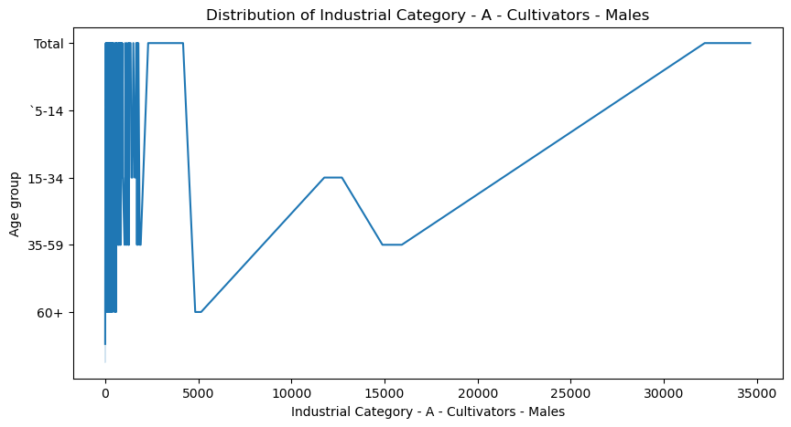

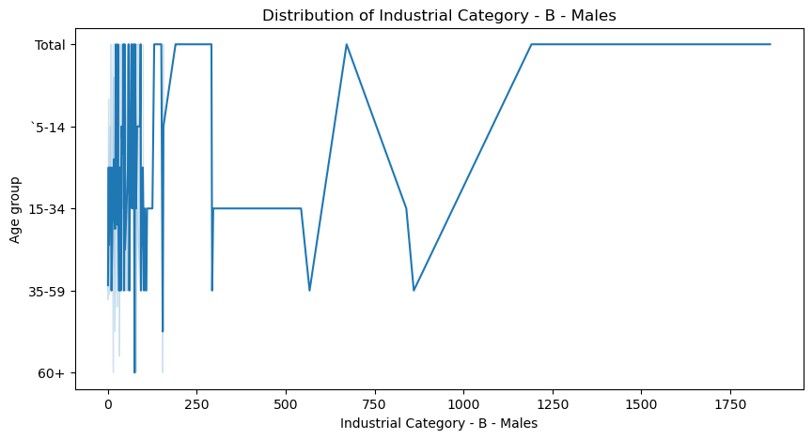

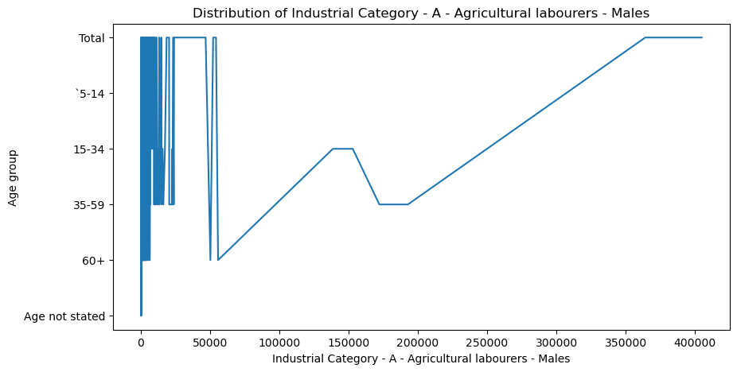

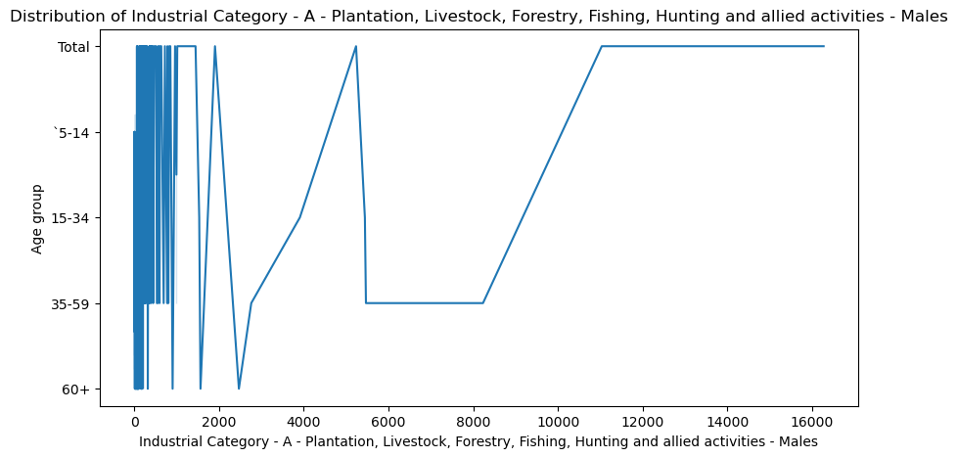

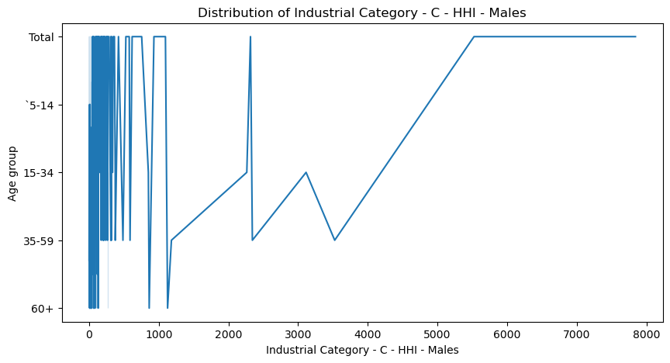

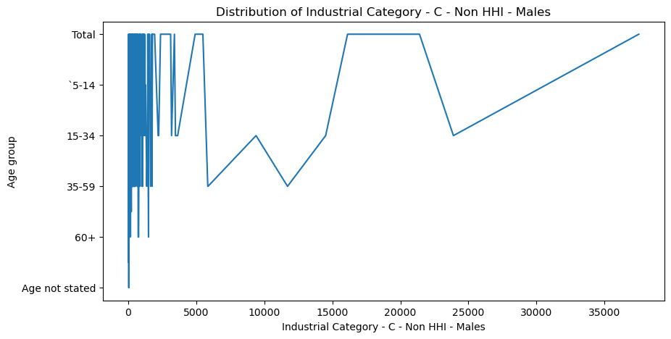

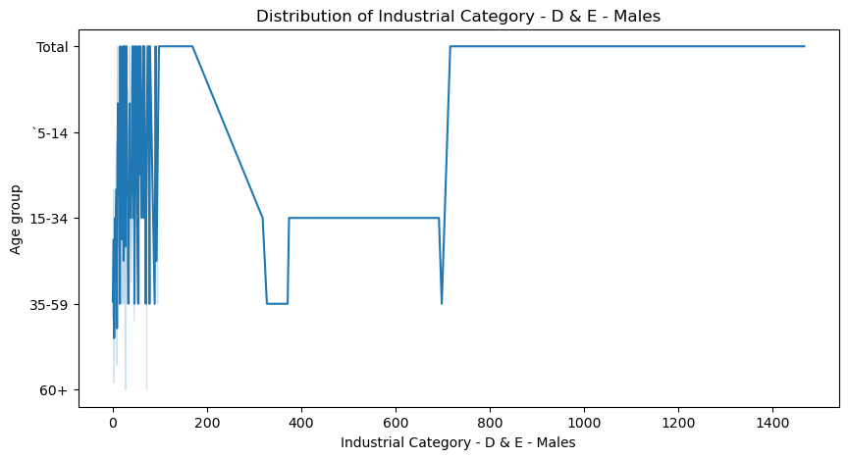

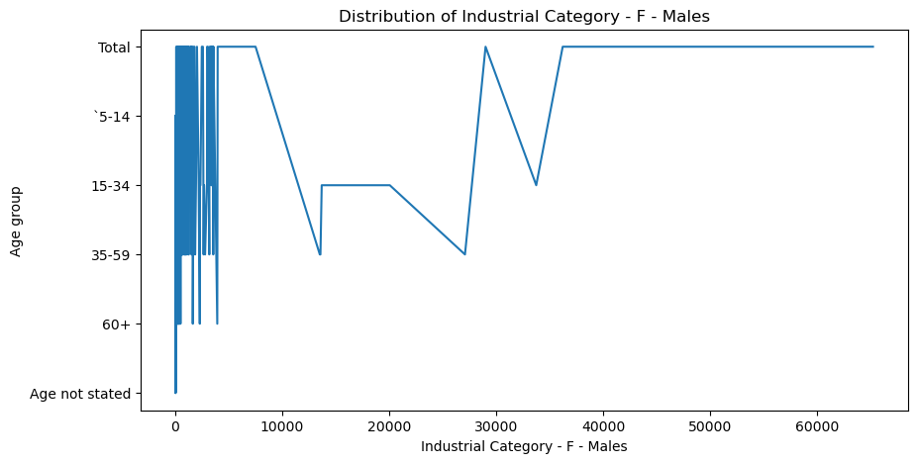

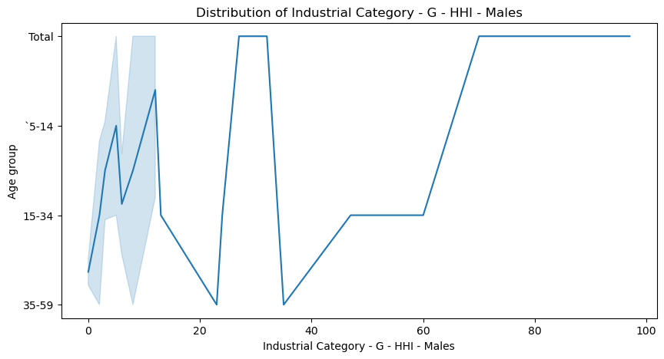

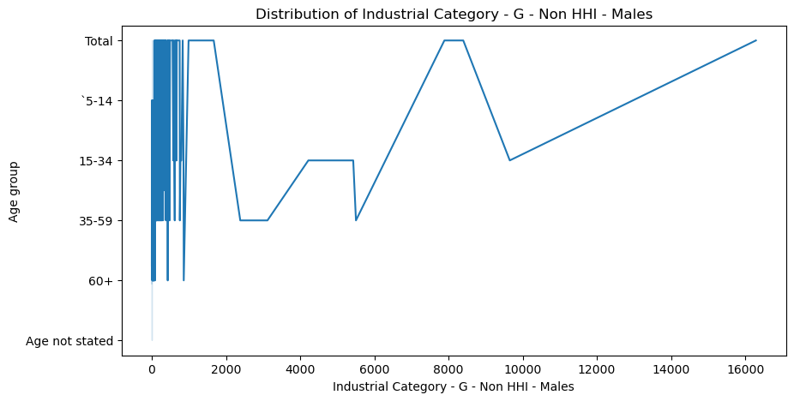

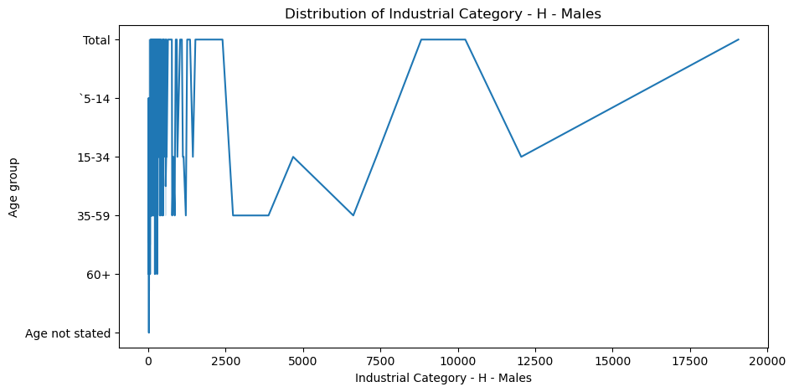

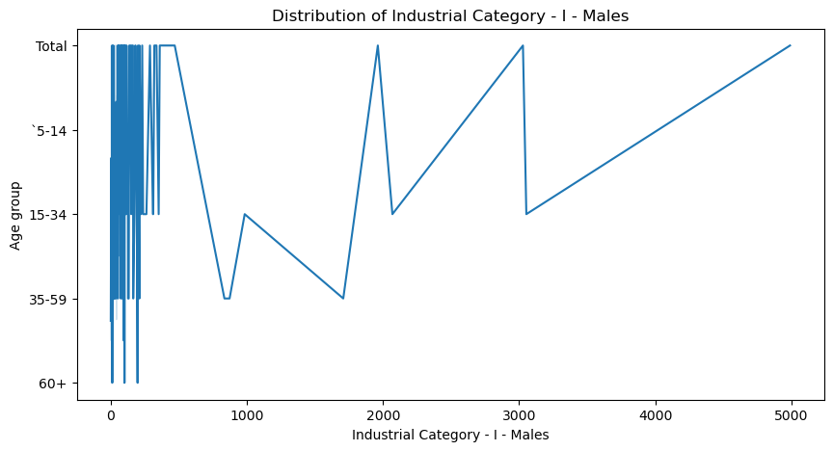



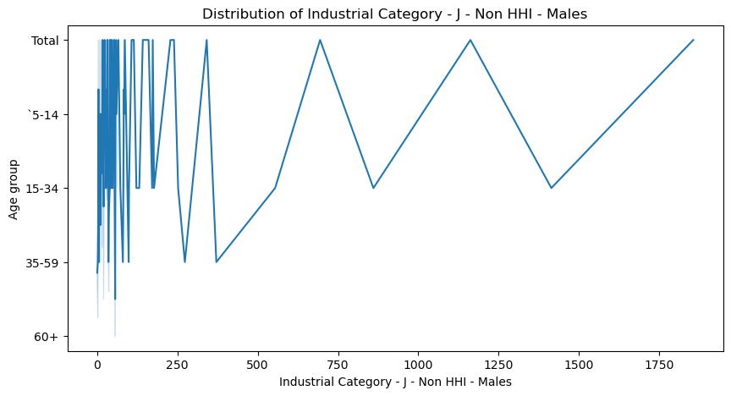

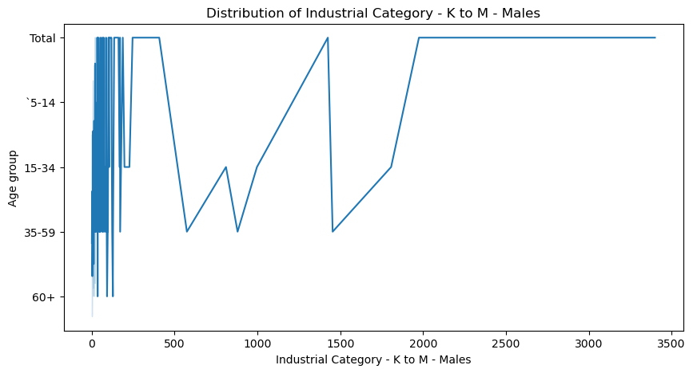

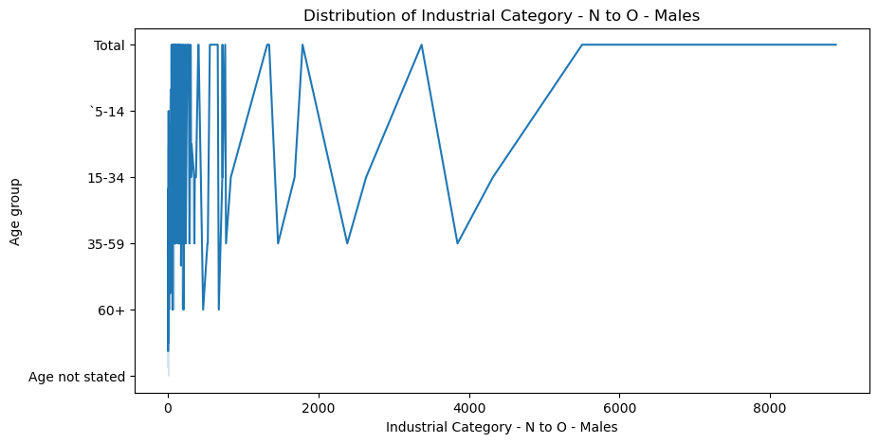

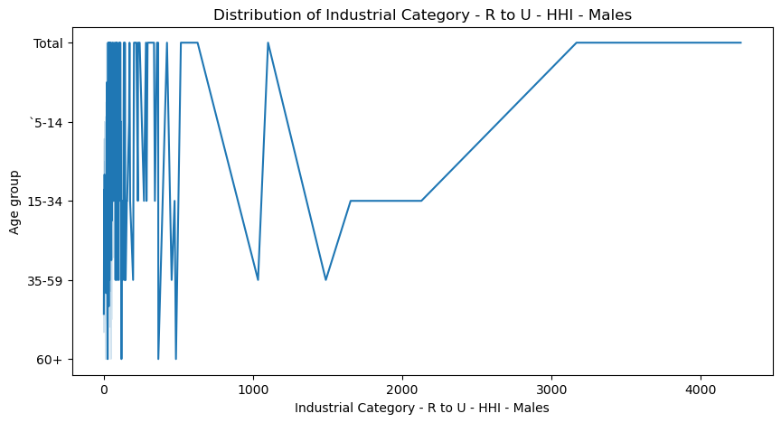

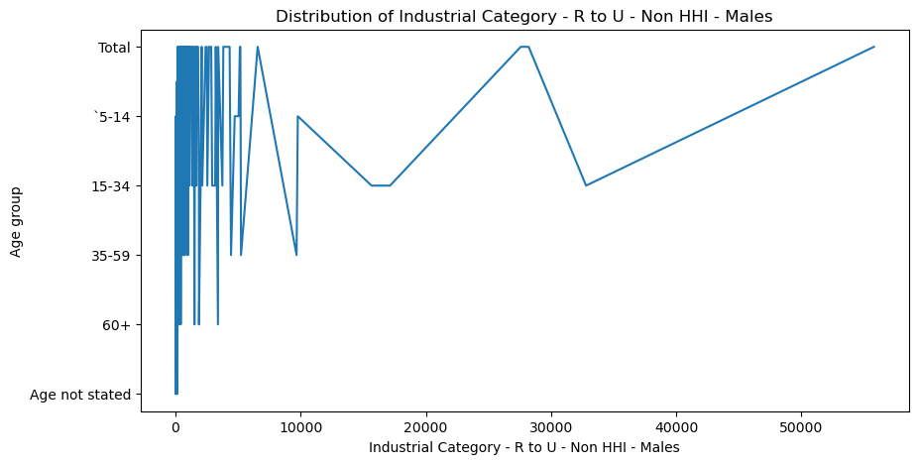

**INDUSTRIAL CATEGORY PERSON**:

Industrial_category_person = ['Industrial Category - A - Cultivators - Persons', 'Industrial Category - A - Agricultural labourers - Persons', 'Industrial Category - A - Plantation, Livestock, Forestry, Fishing, Hunting and allied activities - Persons', 'Industrial Category - B - Persons','Industrial Category - C - HHI - Persons','Industrial Category - C - Non HHI - Persons','Industrial Category - D & E - Persons','Industrial Category - F - Persons','Industrial Category - G - HHI - Persons', 'Industrial Category - G - Non HHI - Persons','Industrial Category - H - Persons','Industrial Category - I - Persons', 'Industrial Category - J - HHI - Persons','Industrial Category - J - Non HHI - Persons','Industrial Category - K to M - Persons', 'Industrial Category - N to O - Persons','Industrial Category - P to Q - Persons','Industrial Category - R to U - HHI - Persons','Industrial Category - R to U - Non HHI - Persons']

**VISUALIZATION BY INDUSTRIAL CATEGORY PERSON**:

for colum1 in Industrial_category_person:

plt.figure(figsize=(10,5))

sns.lineplot(data=df, x=column, y='Age group')

plt.title(f'Distribution of {colum1}')

plt.show()

**OUTPUT:**

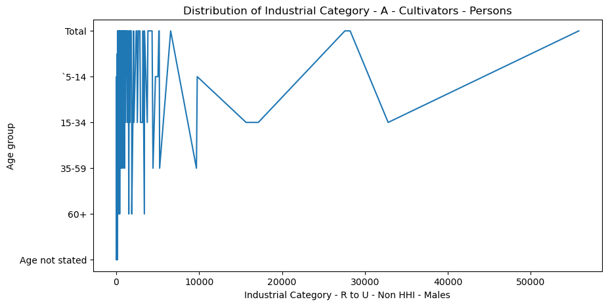

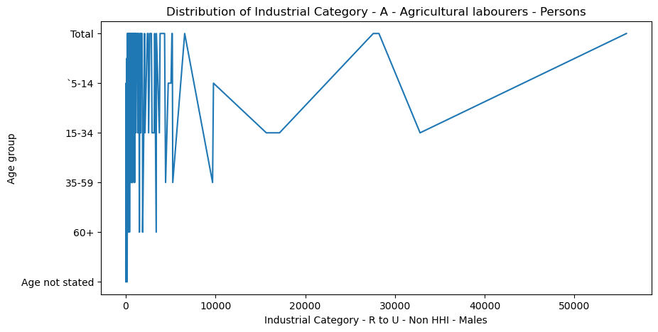

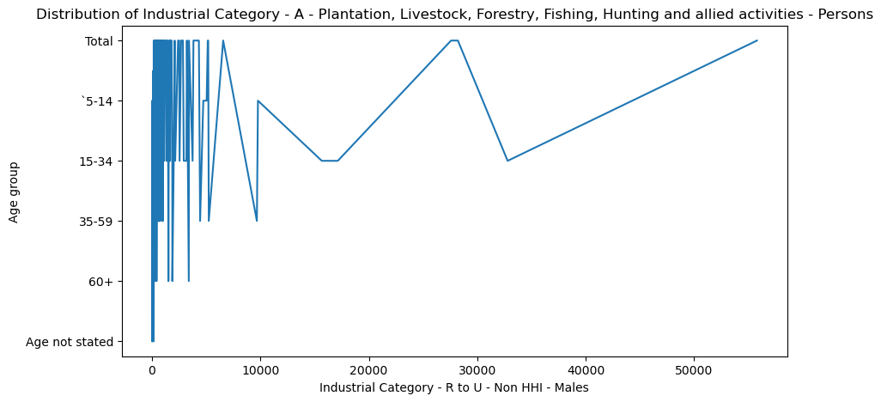

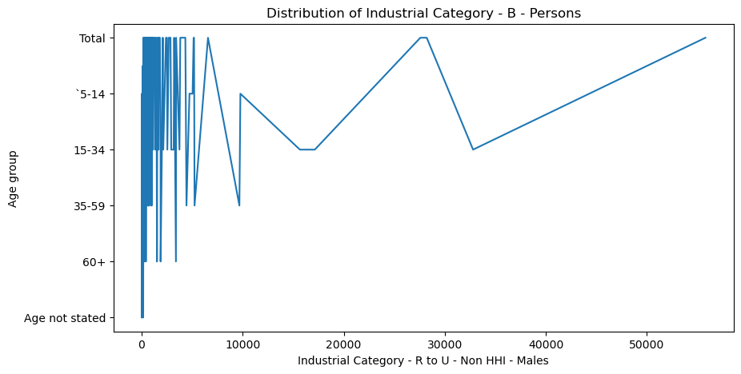

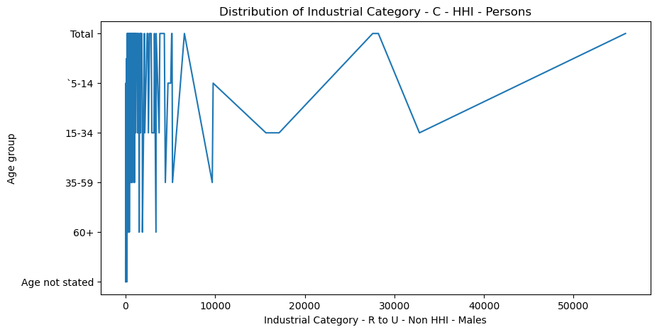

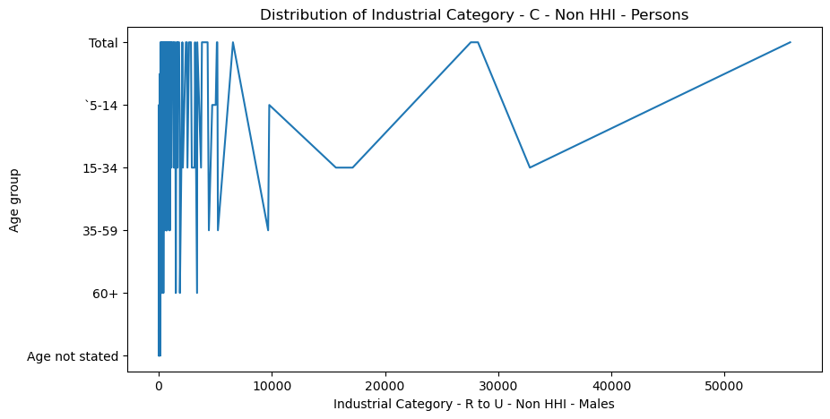

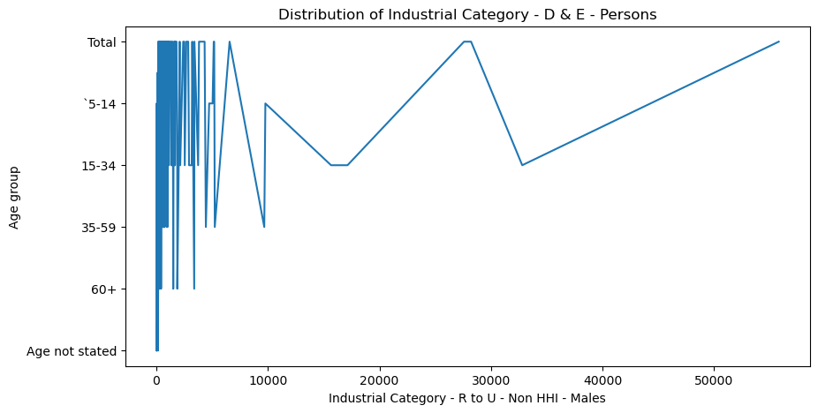

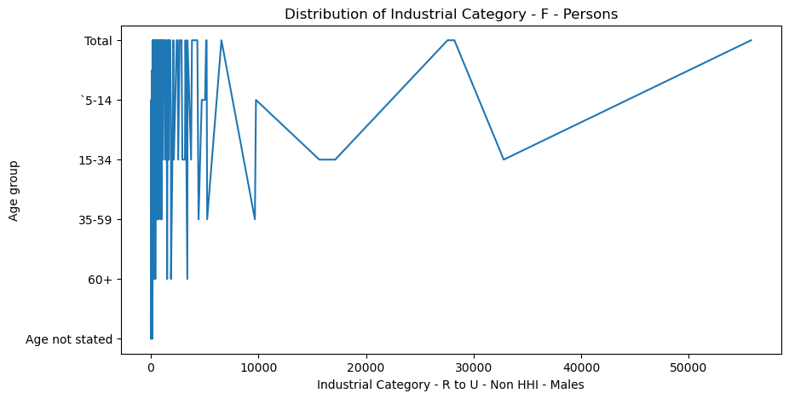

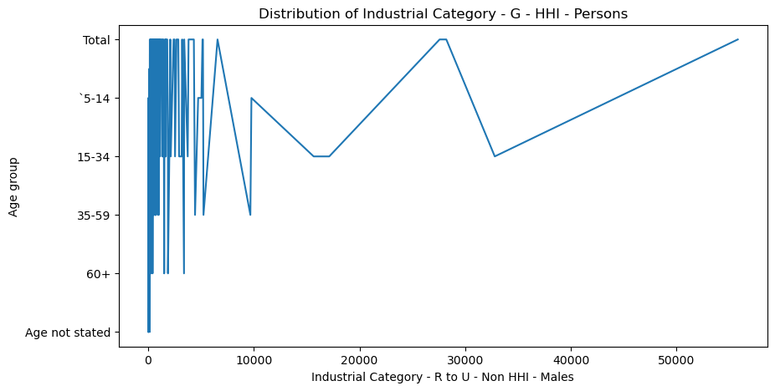

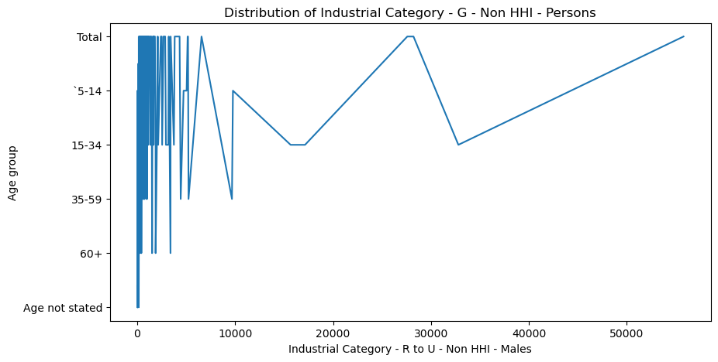

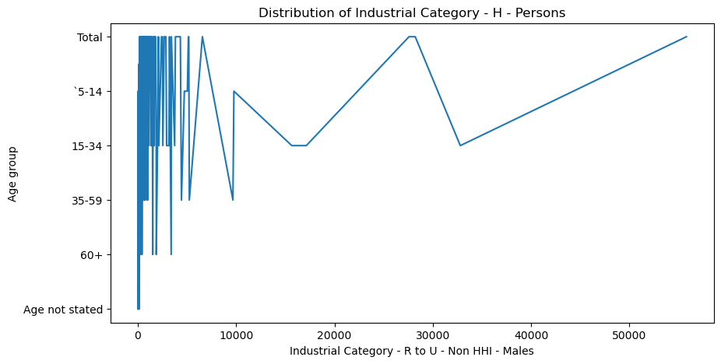

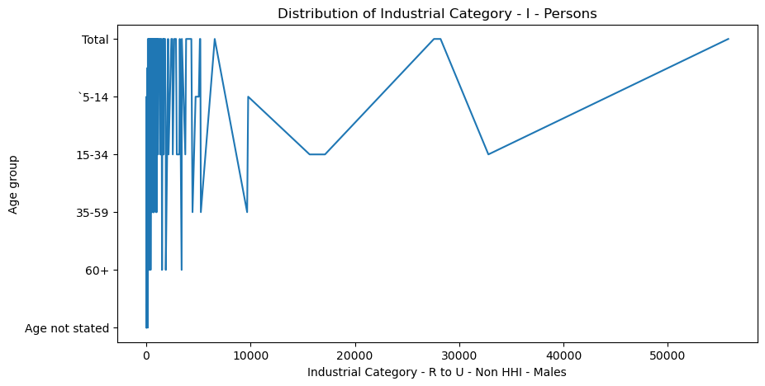

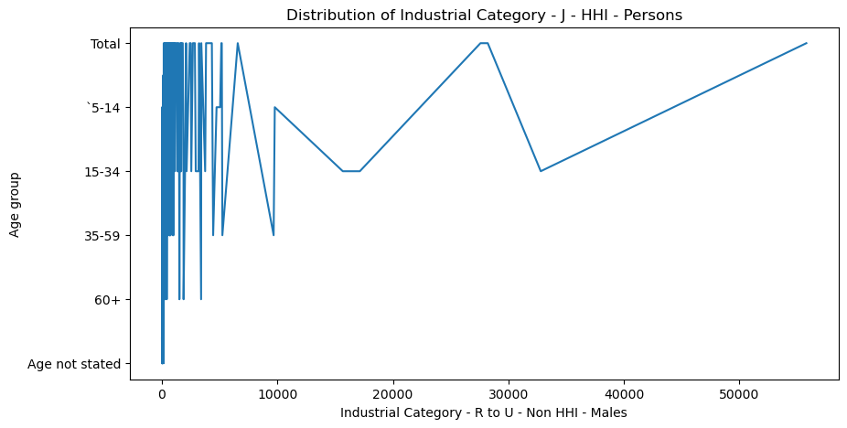

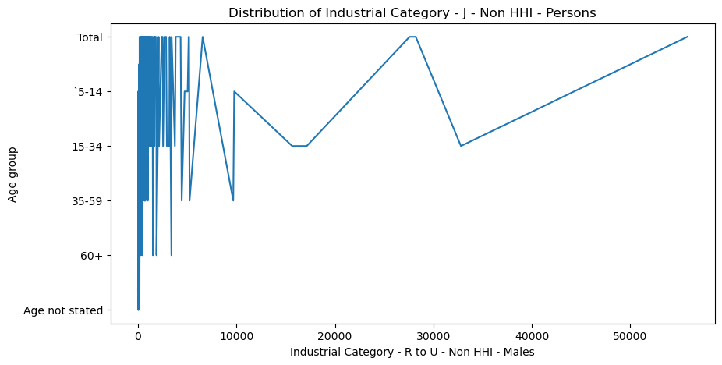

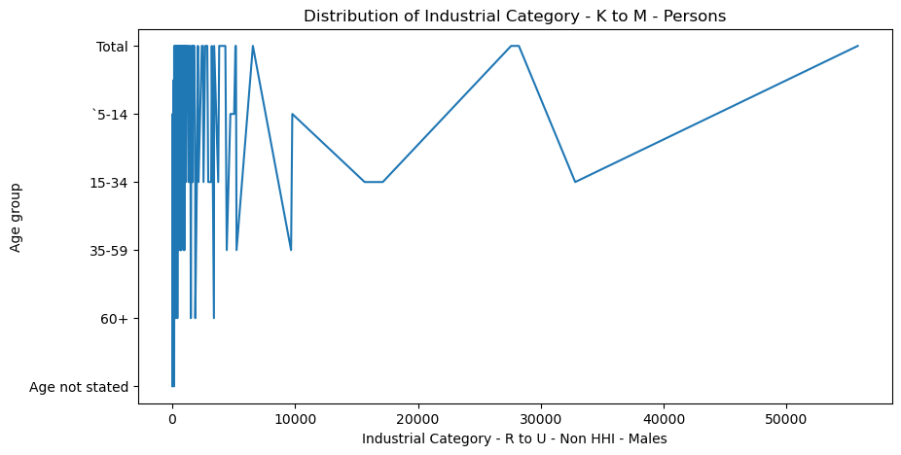

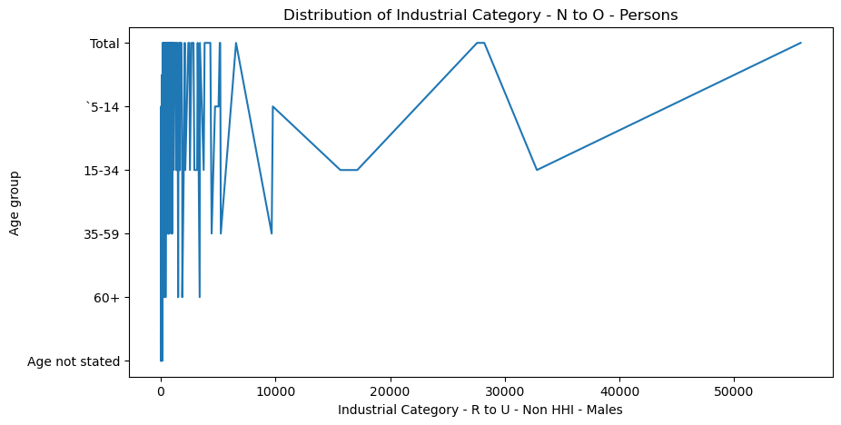

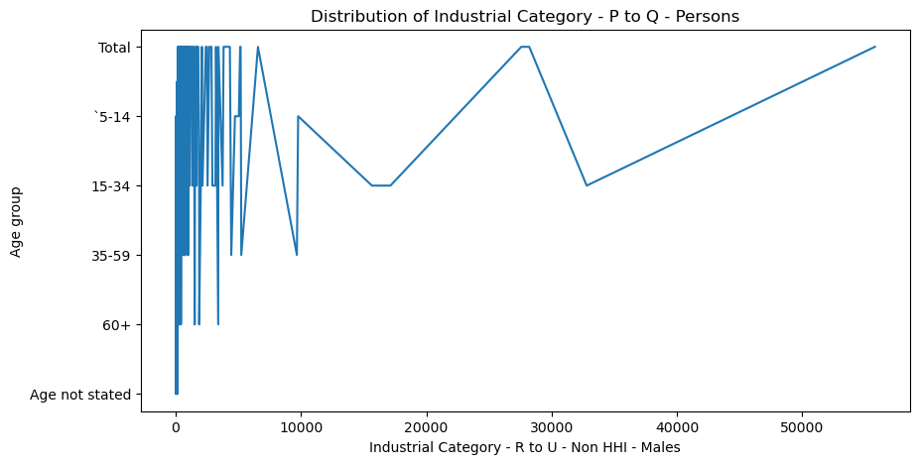

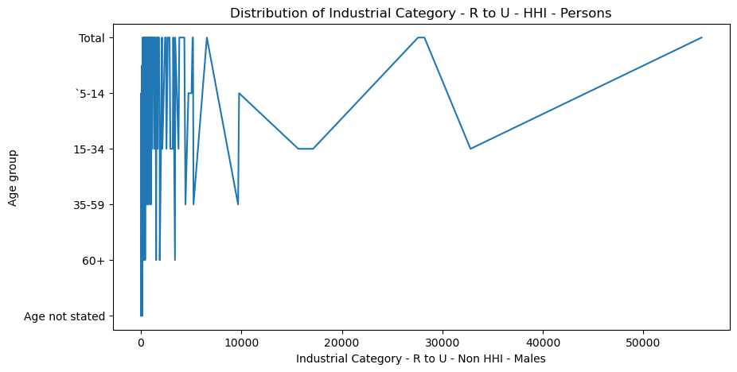

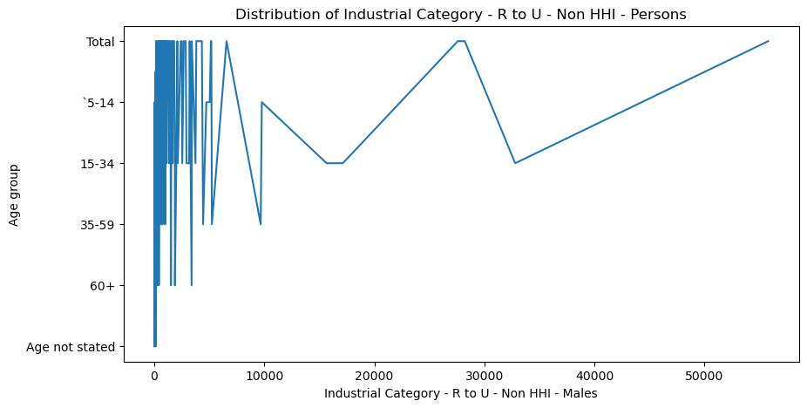

**INDUSTRIAL CATEGORY FEMALE**:

Industrial_category_female = ['Industrial Category - A - Cultivators - Females', 'Industrial Category - A - Agricultural labourers - Females', 'Industrial Category - A - Plantation, Livestock, Forestry, Fishing, Hunting and allied activities - Females', 'Industrial Category - B - Females', 'Industrial Category - C - HHI - Females' ,'Industrial Category - C - Non HHI - Females', 'Industrial Category - D & E - Females','Industrial Category - F - Females', 'Industrial Category - G - HHI - Females' ,'Industrial Category - G - Non HHI - Females', 'Industrial Category - H - Females', 'Industrial Category - I - Females' ,'Industrial Category - J - HHI - Females','Industrial Category - J - Non HHI - Females' ,'Industrial Category - K to M - Females', 'Industrial Category - N to O - Females','Industrial Category - P to Q - Females', 'Industrial Category - R to U - HHI - Females', 'Industrial Category - R to U - Non HHI - Females']

**VISUALIZATION BY INDUSTRIAL CATEGORY FEMALE**:

for column2 in Industrial_category_female:

plt.figure(figsize=(10,5))

sns.lineplot(data=df, x=column2, y='Age group')

plt.title(f'Distribution of {column2}')

plt.show()

**OUTPUT:**

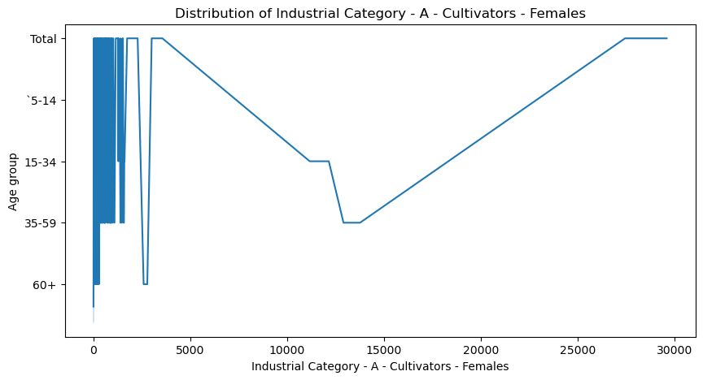

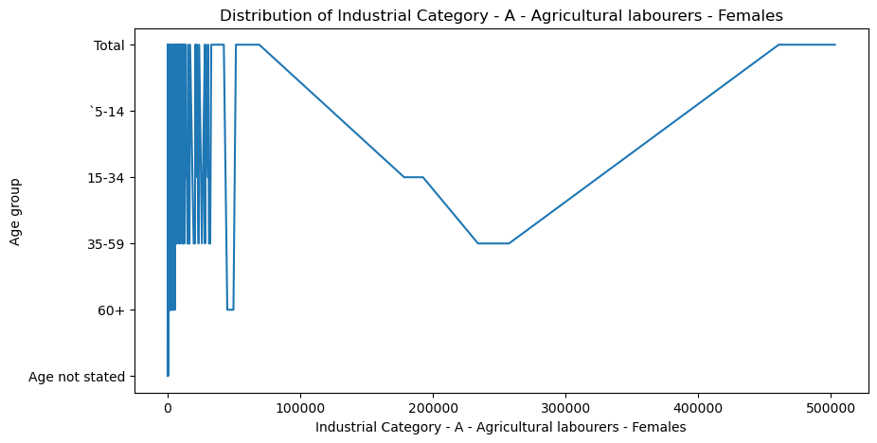

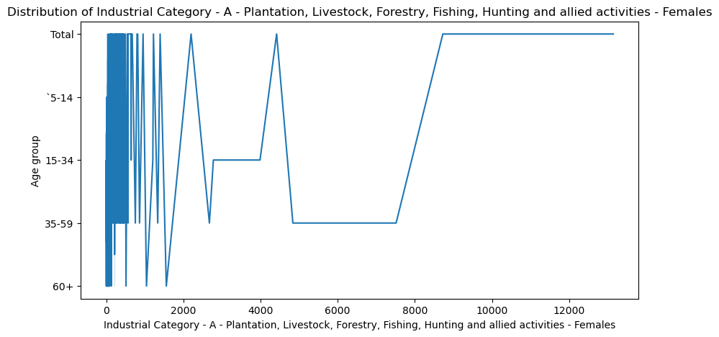

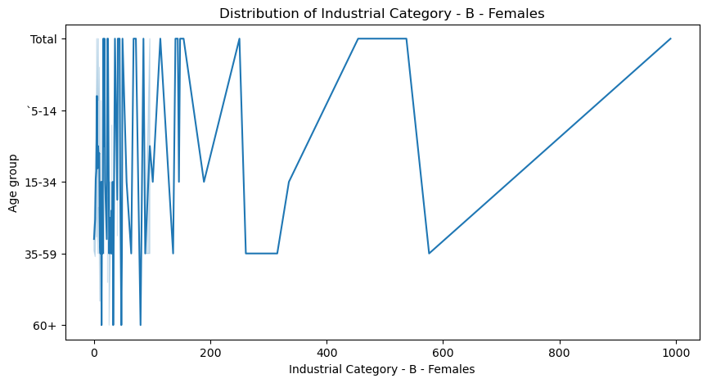

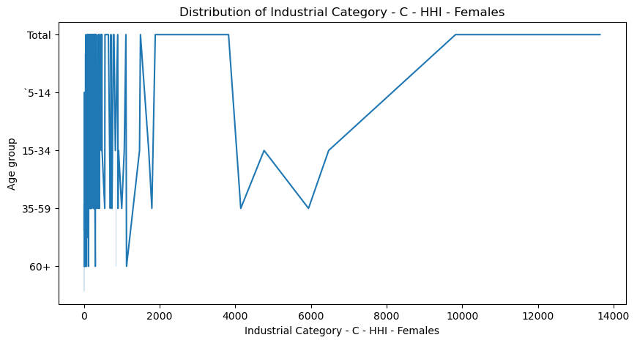

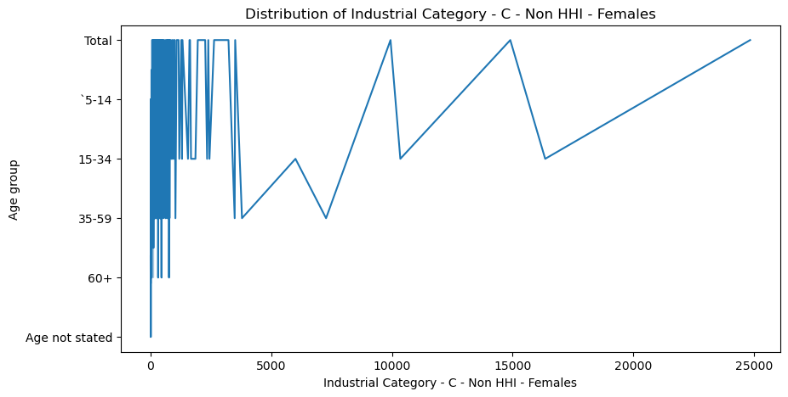

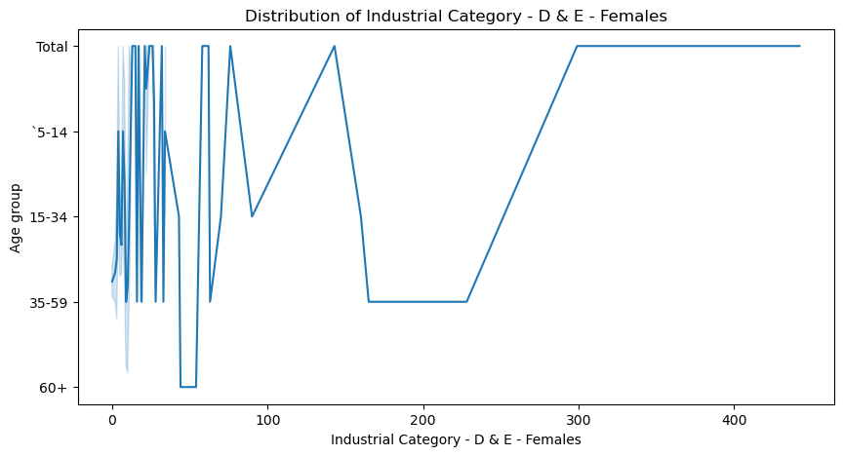

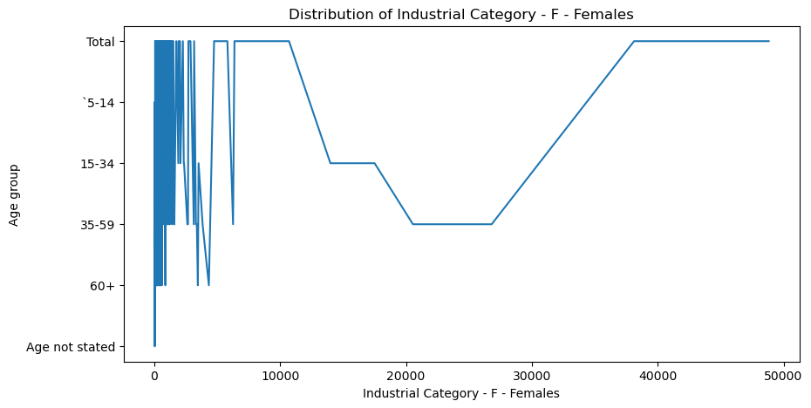

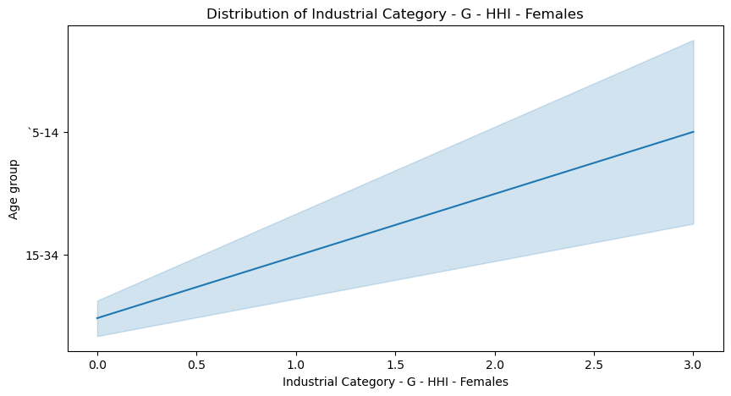

. 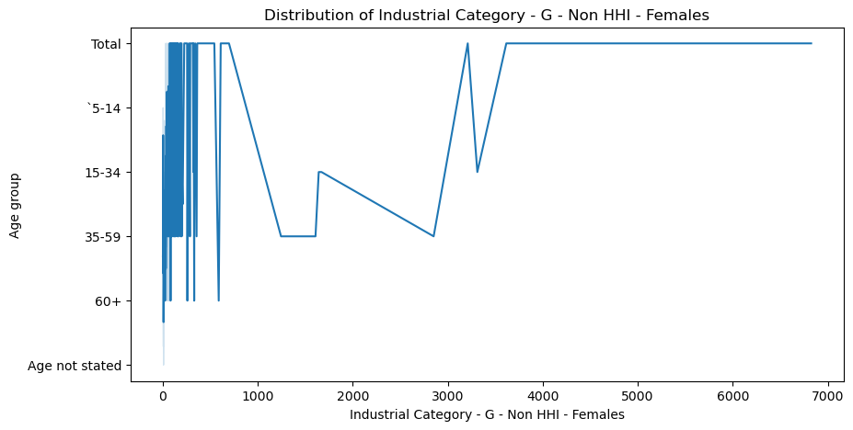

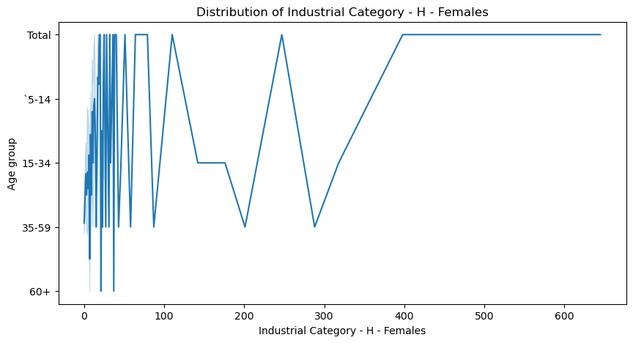

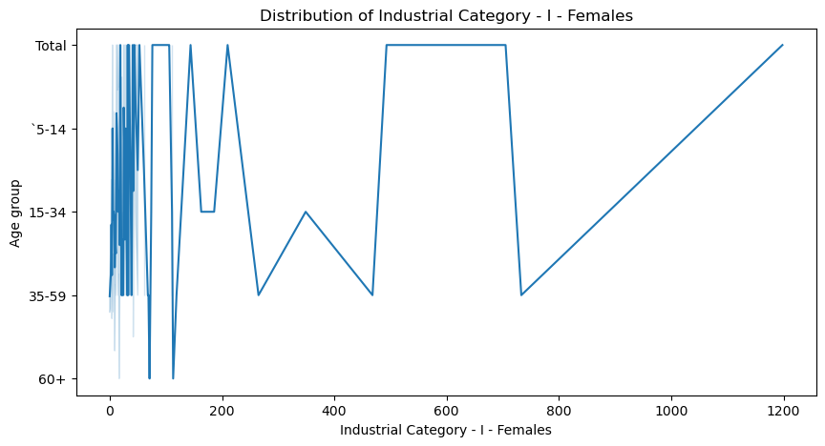

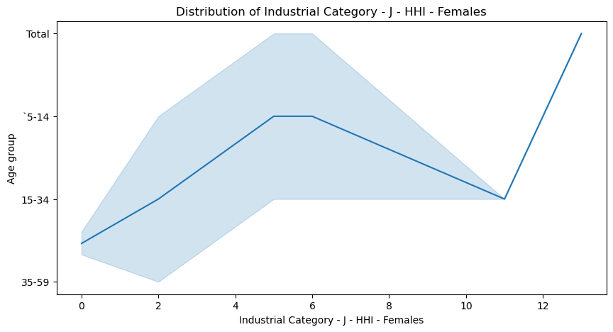

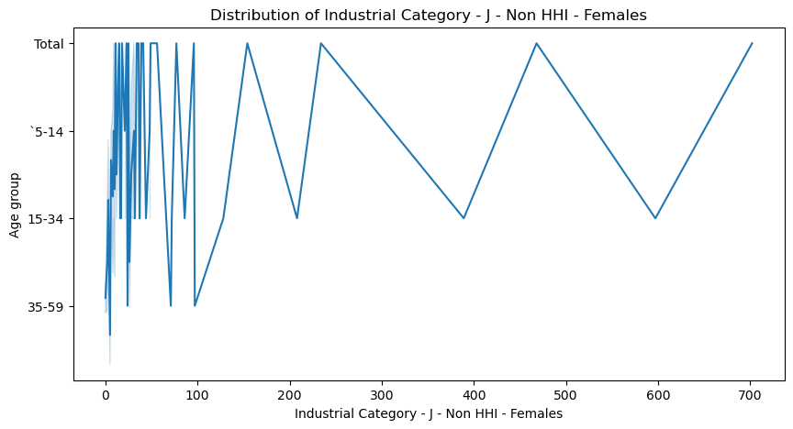

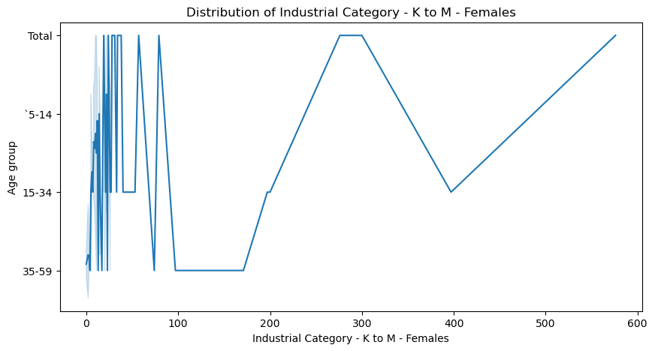

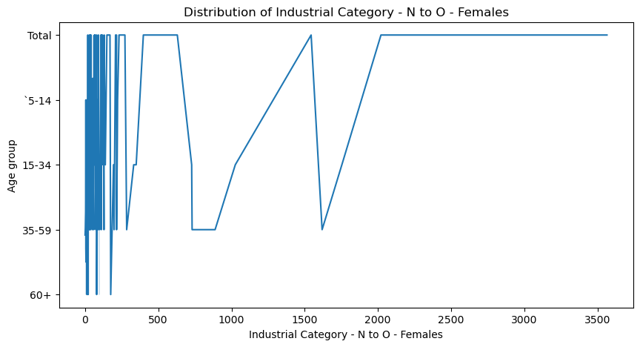

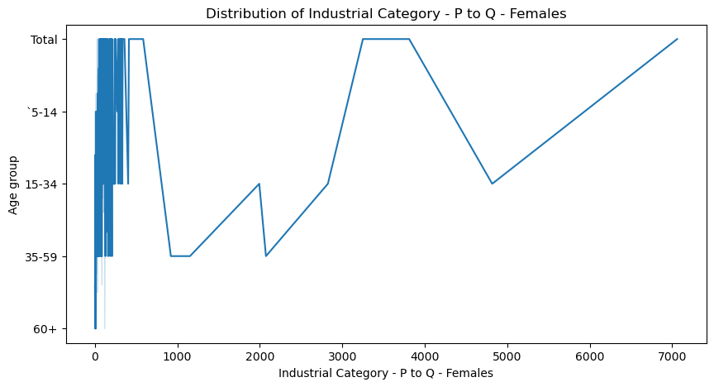

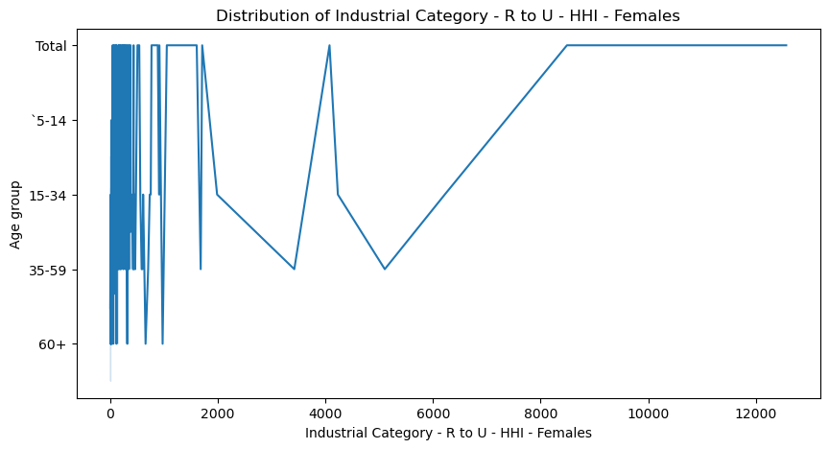

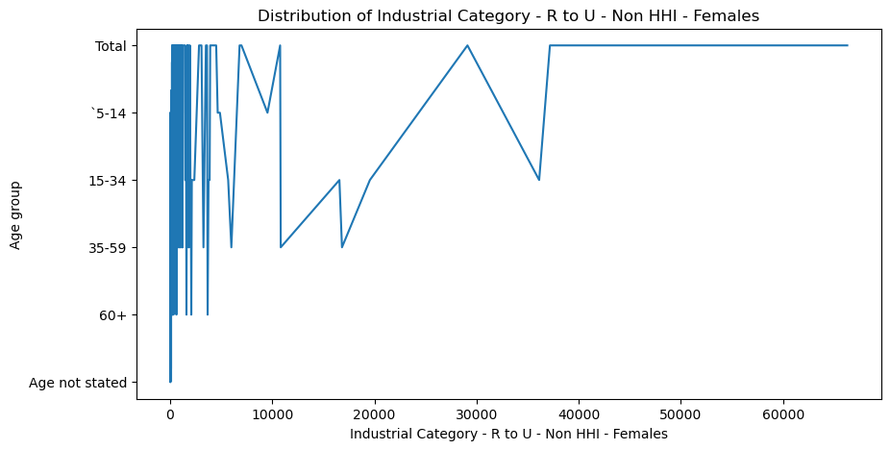

**INDUSTRIAL CATEGORY WORKERS**:

male_workers = ['Worked for 3 months or more but less than 6 months - Males', 'Worked for less than 3 months - Males']

female_workers = ['Worked for 3 months or more but less than 6 months - Females', 'Worked for less than 3 months - Females']

person_workers = ['Worked for 3 months or more but less than 6 months - Persons', 'Worked for less than 3 months - Persons']

**VISUALIZATION BY INDUSTRIAL CATEGORY MALE WORKERS**:

for column1 in Industrial_category_male:

for work in male_workers:

plt.figure(figsize=(10,5))

sns.lineplot(data=df, x=work, y=column1)

plt.title(f'Distribution of {work}')

plt.show()

**OUTPUT:**

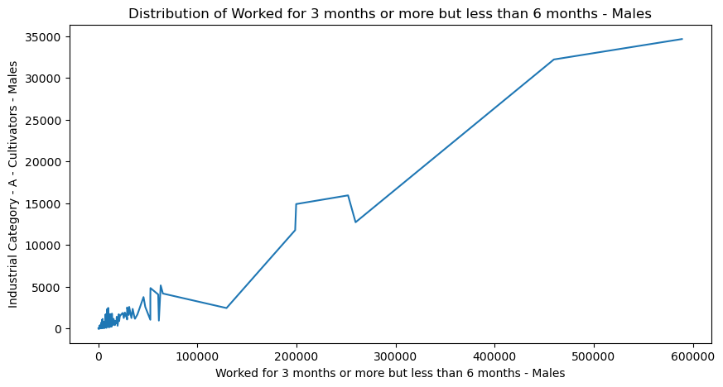

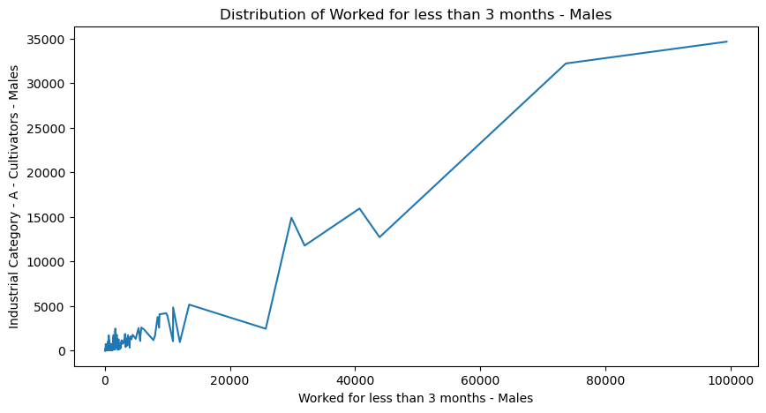

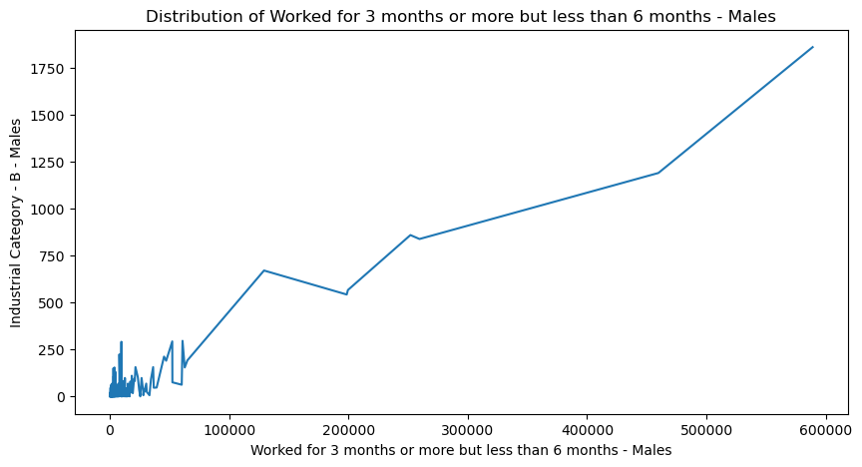

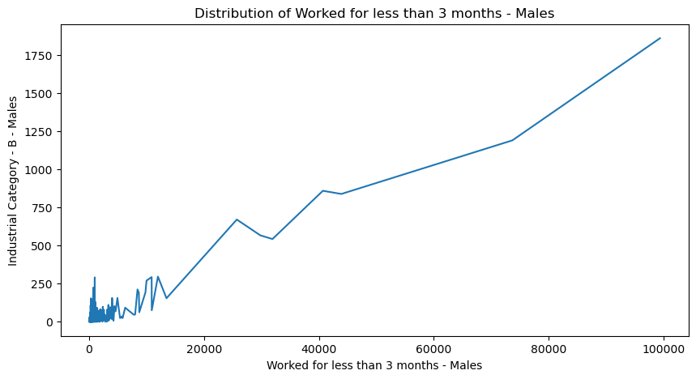

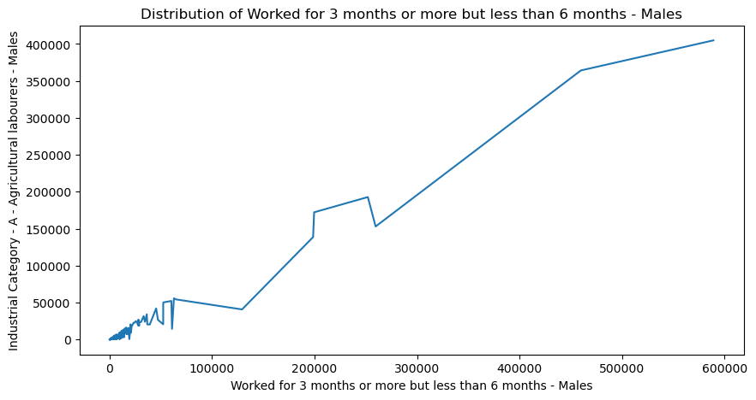

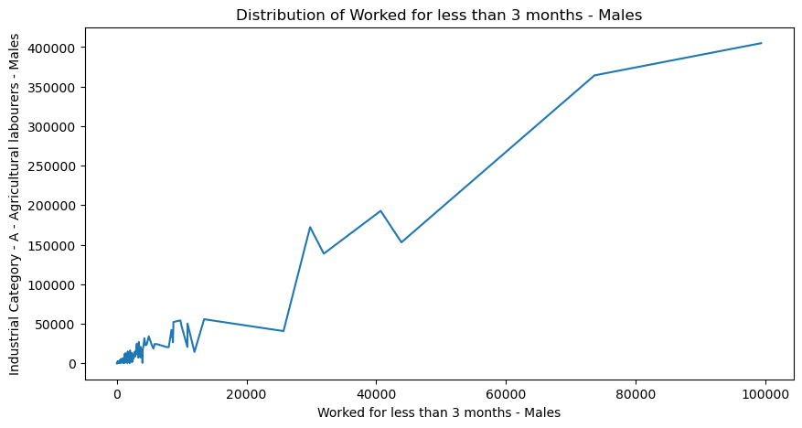

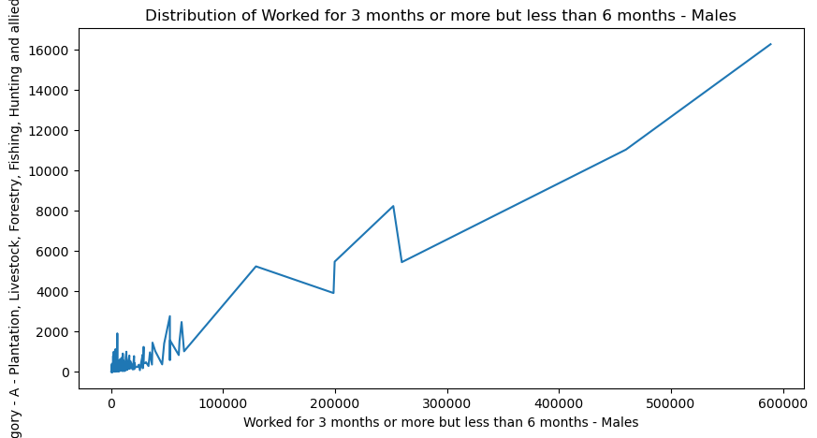

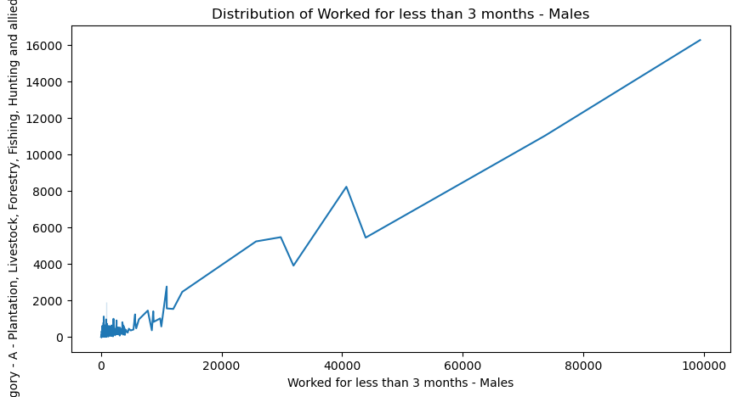

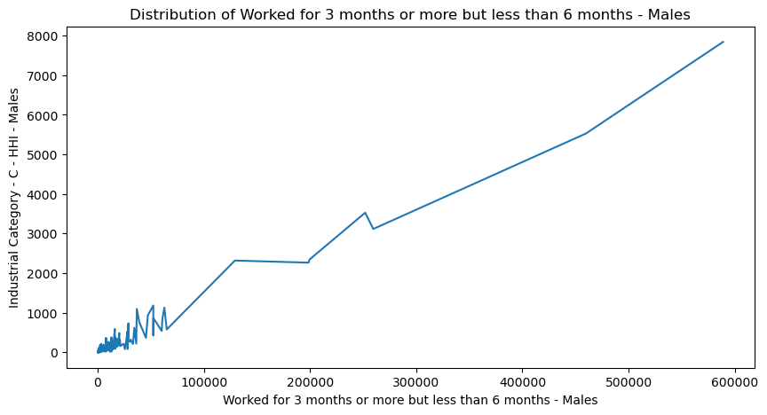

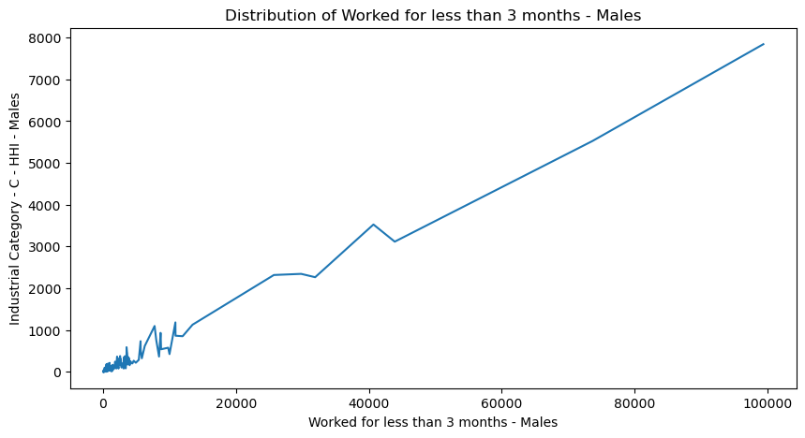

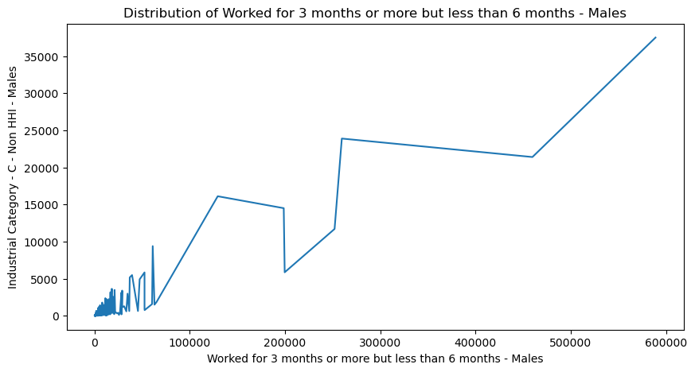

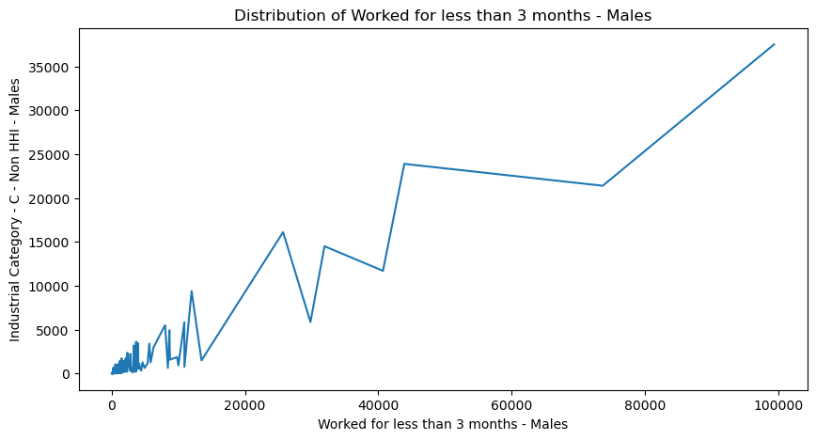

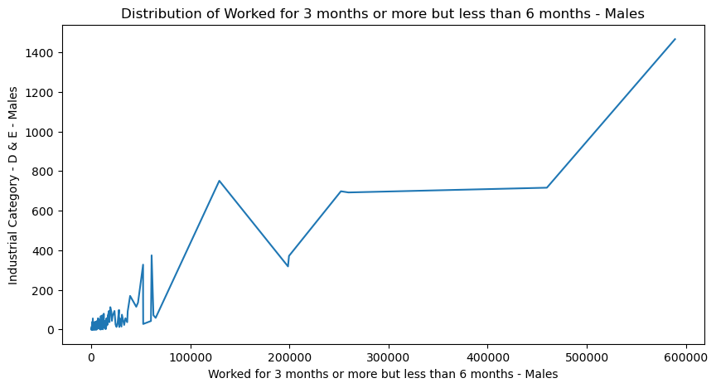

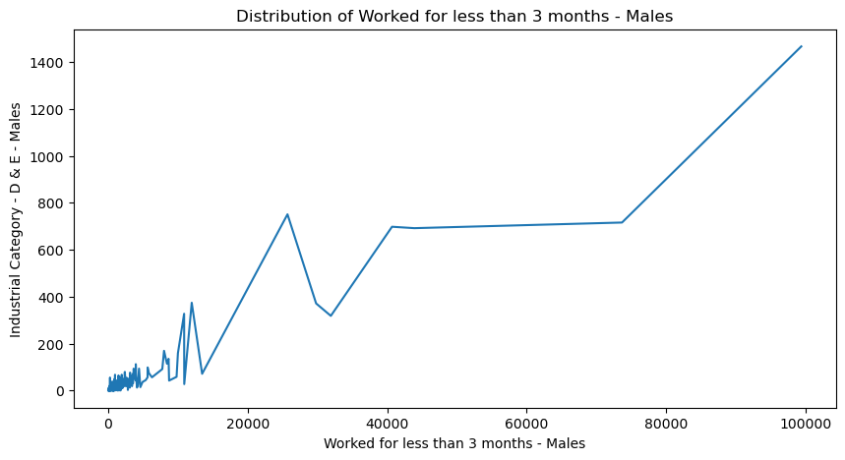

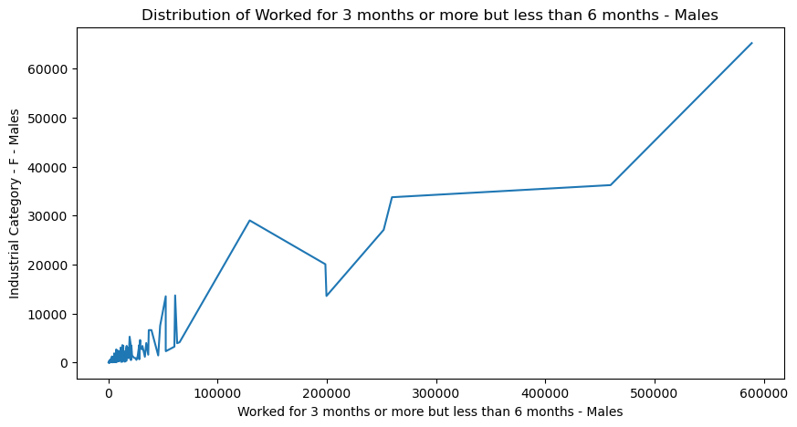

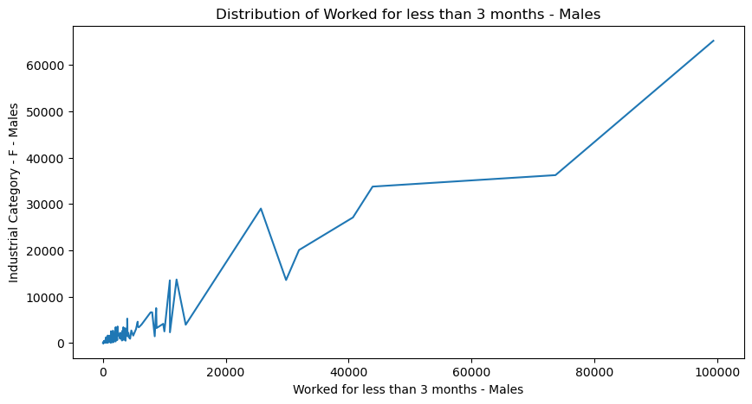

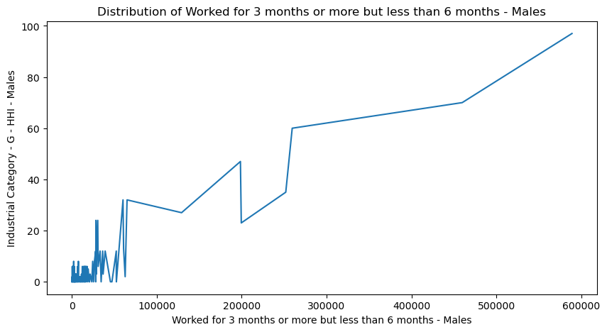

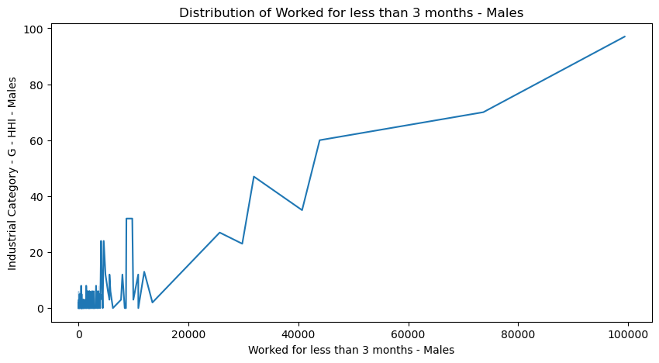

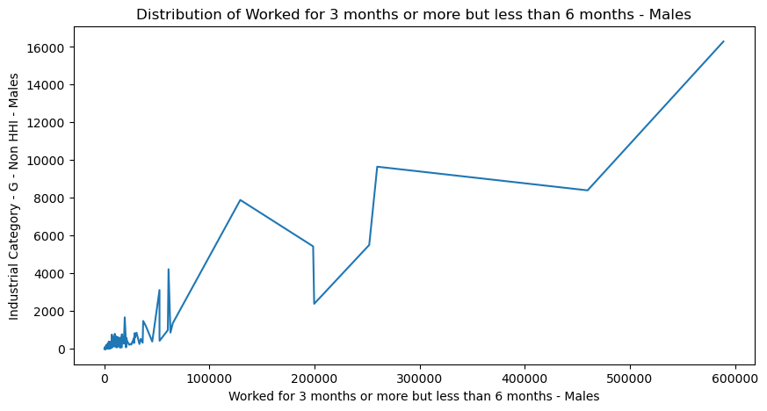

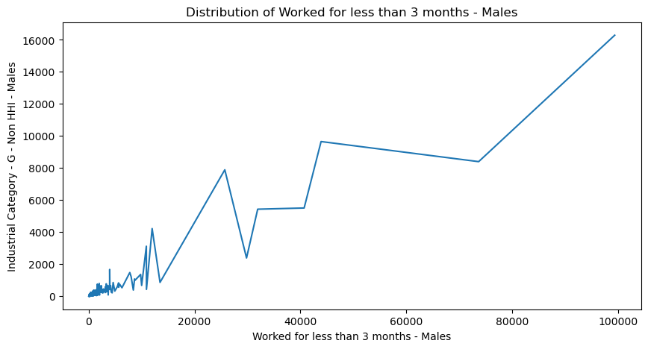

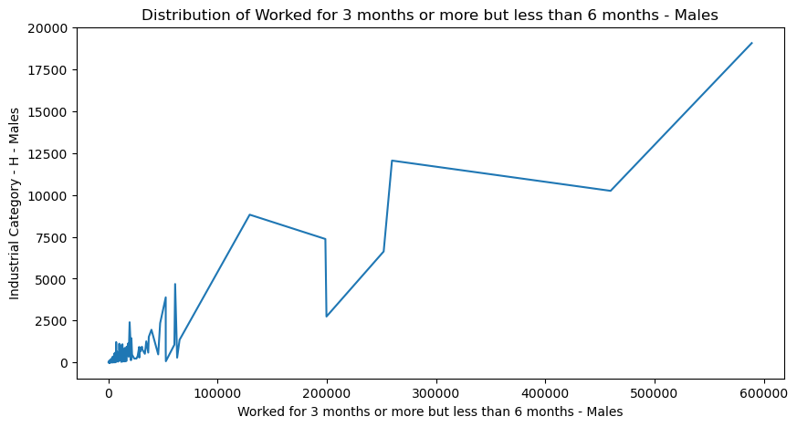

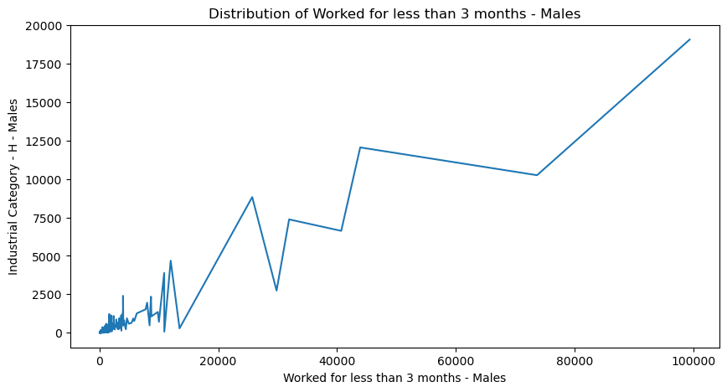

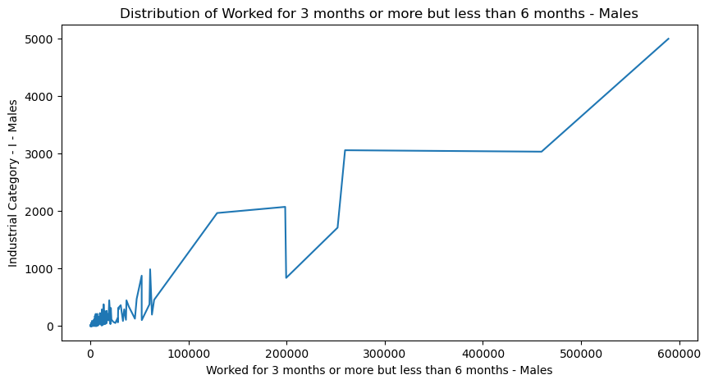

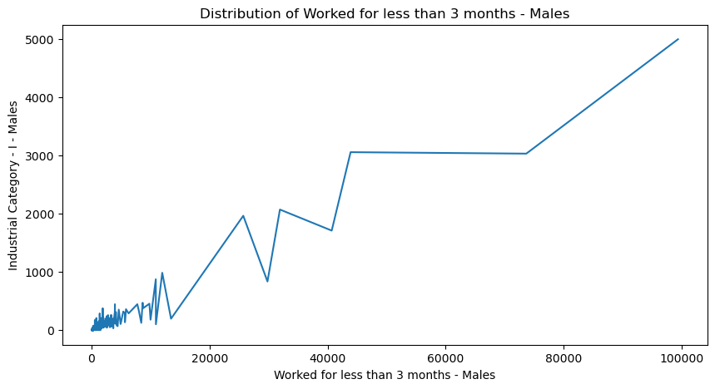

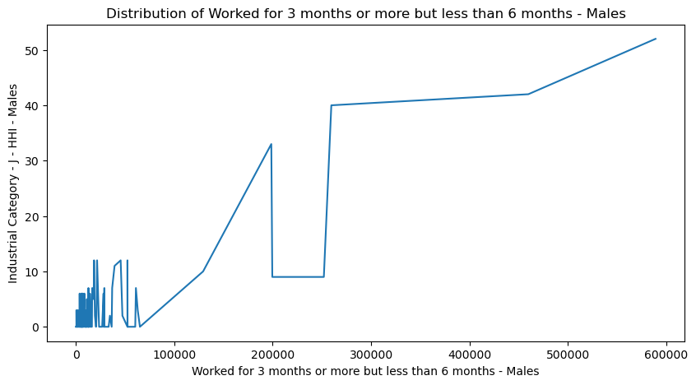

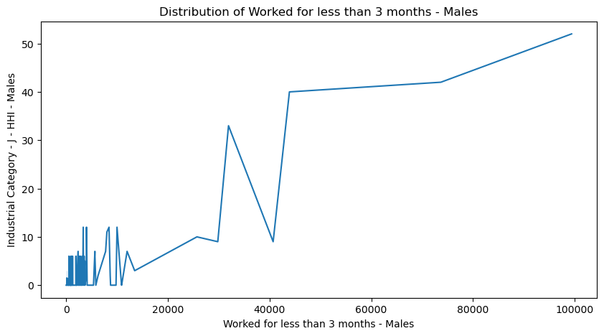

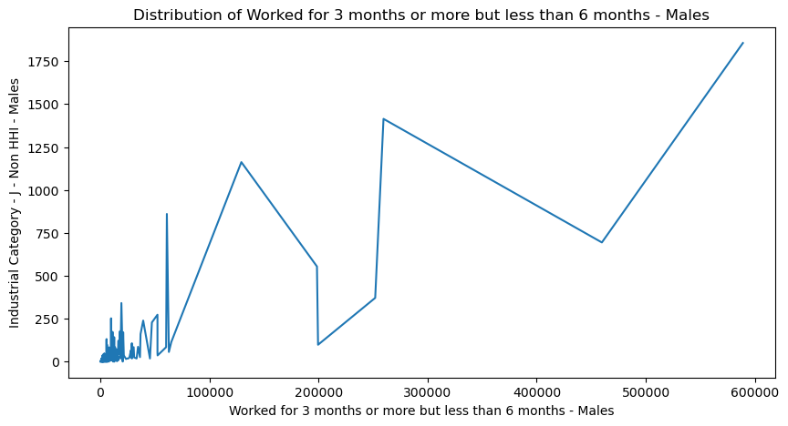

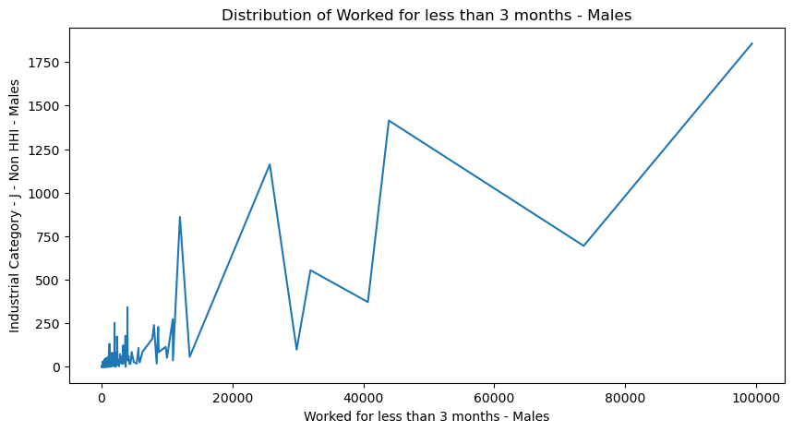

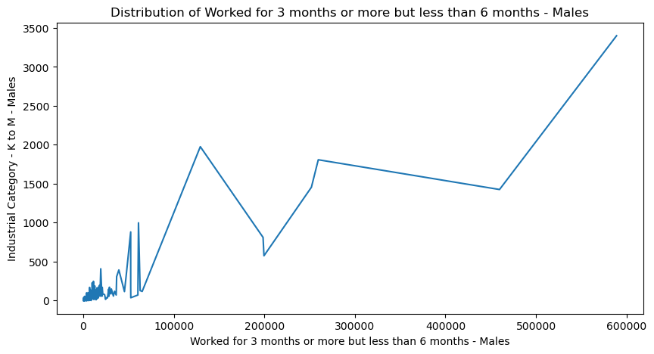

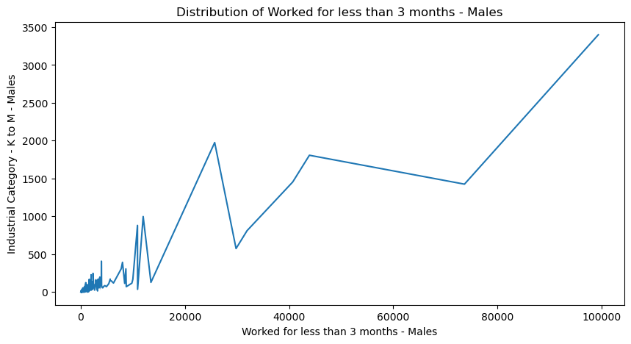

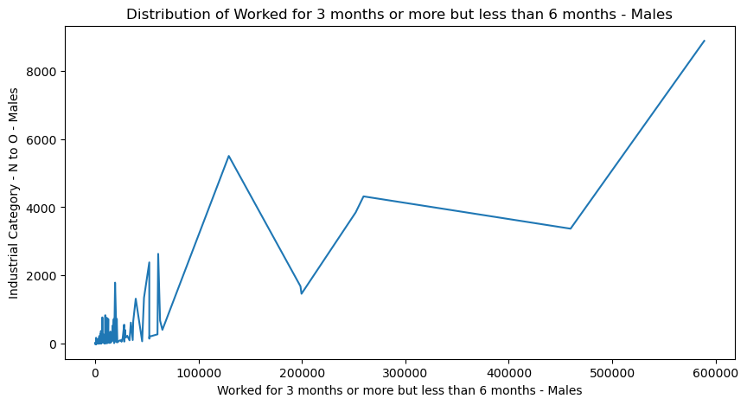

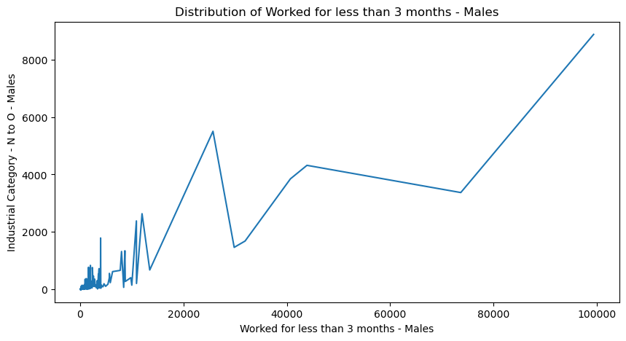

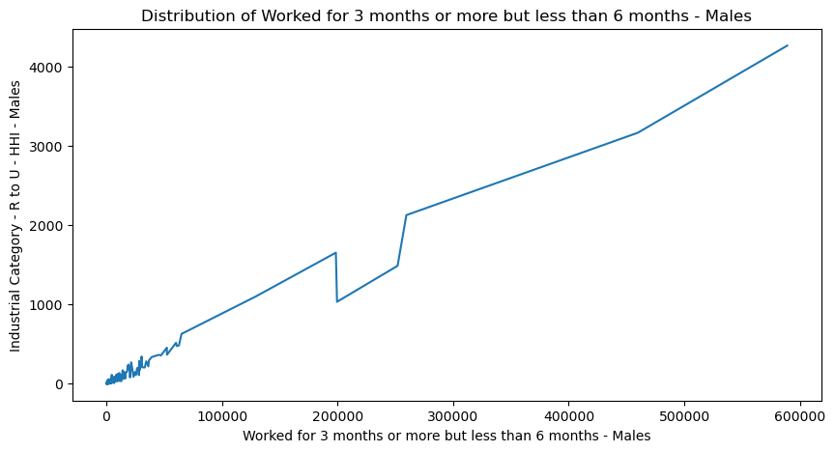

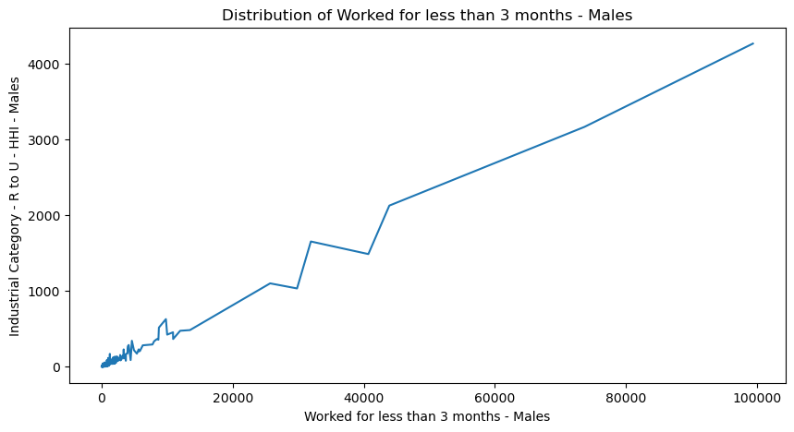

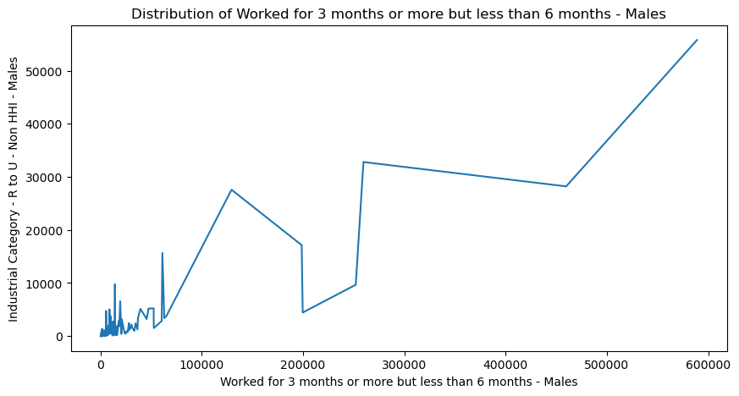

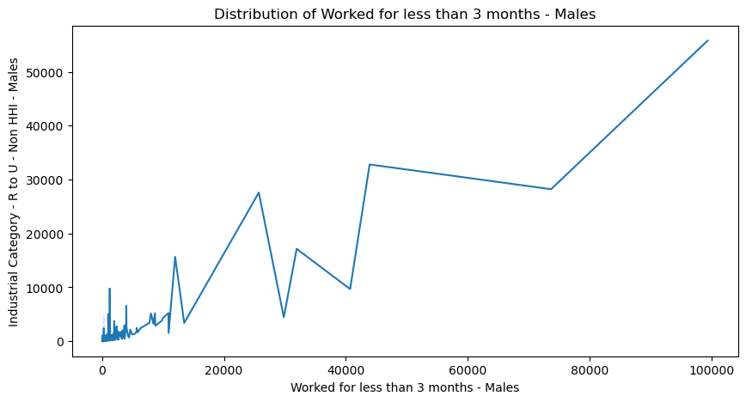

**VISUALIZATION BY INDUSTRIAL CATEGORY FEMALE WORKERS**:

for column2 in Industrial_category_female:

for work1 in female_workers:

plt.figure(figsize=(10,5))

sns.lineplot(data=df, x=work1, y=column2)

plt.title(f'Distribution of {work1}')

plt.show()

**OUTPUT:**

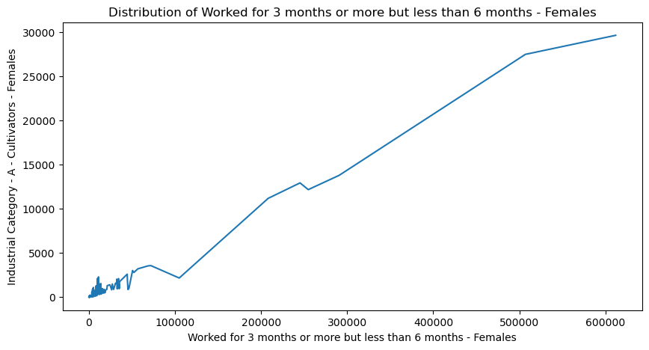

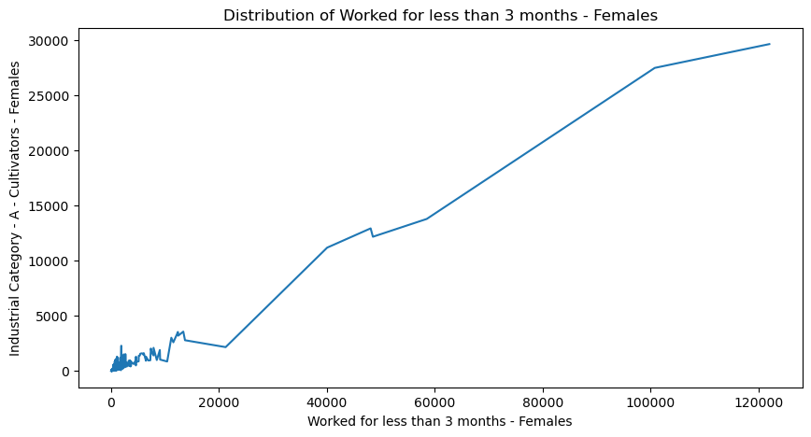

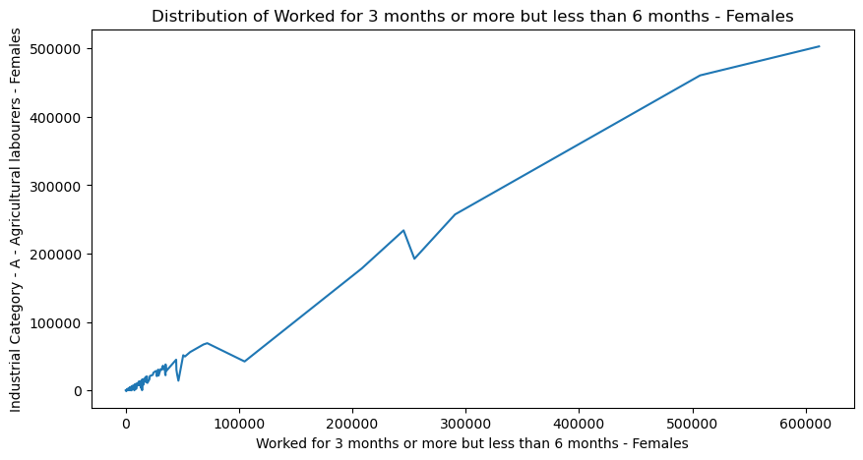

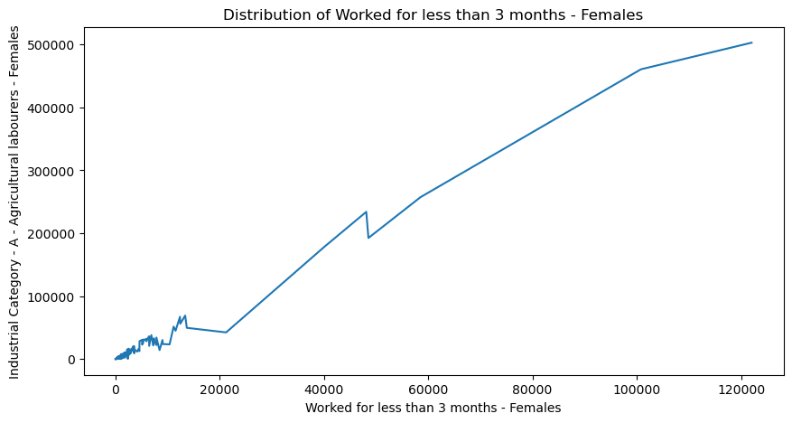

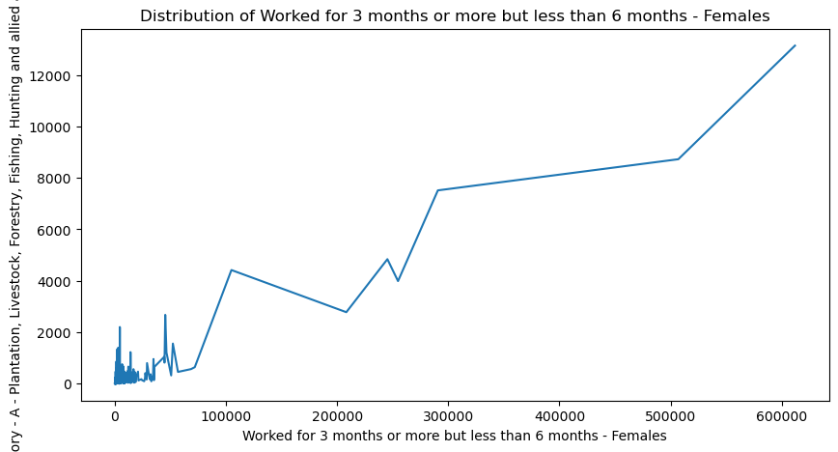

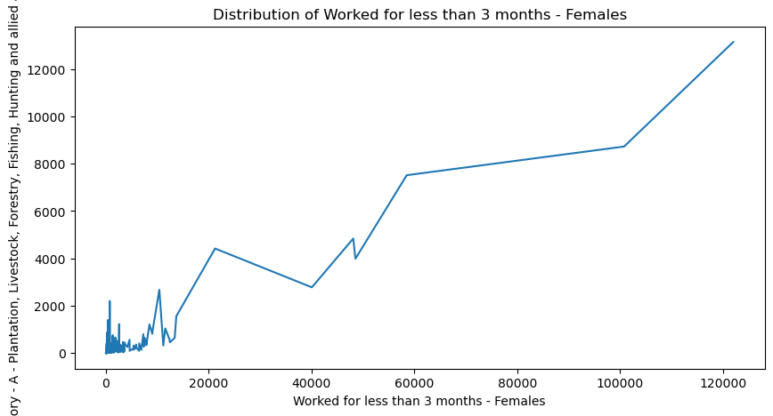

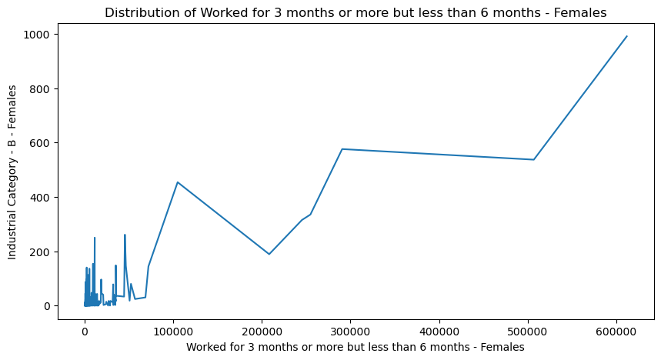

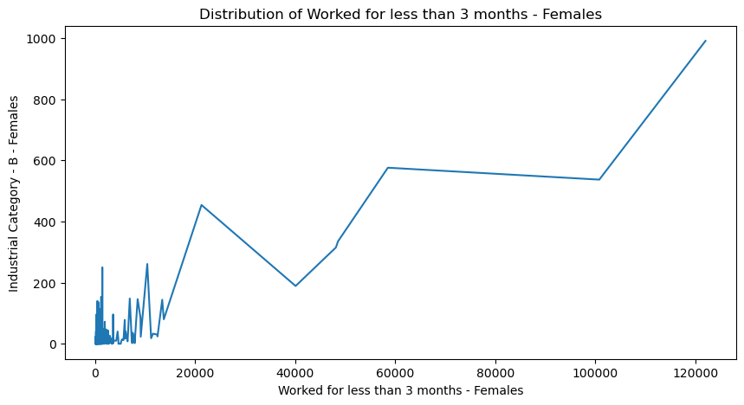

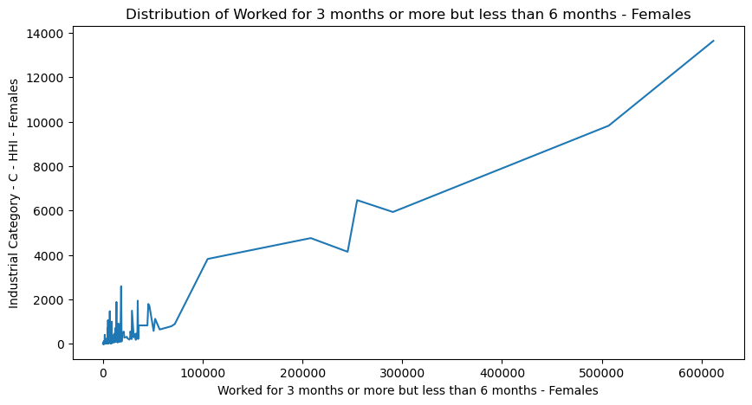

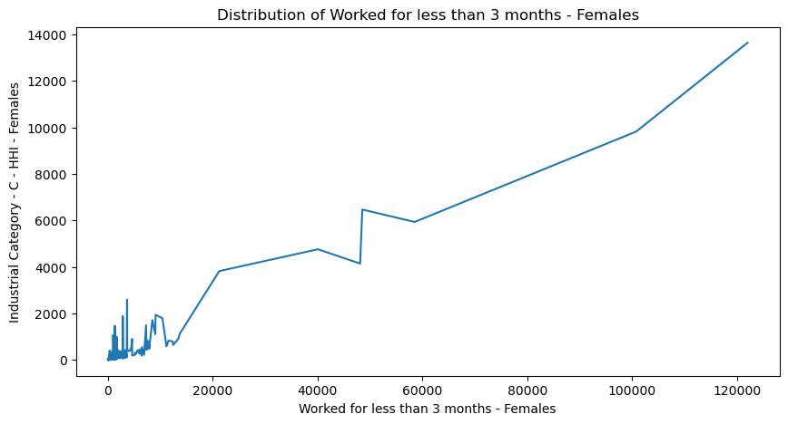

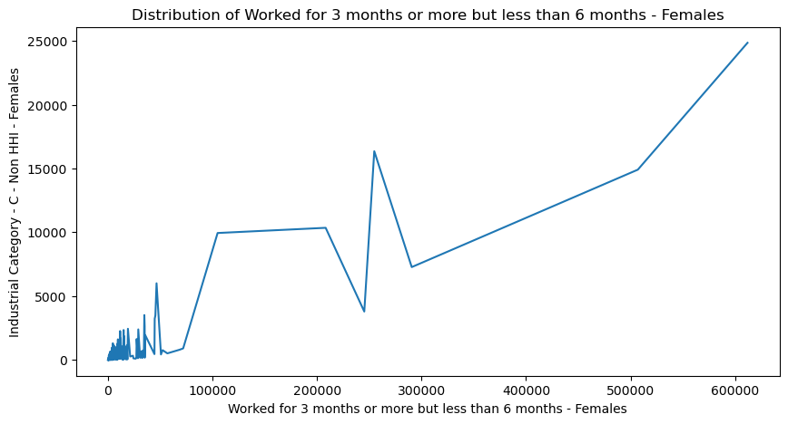

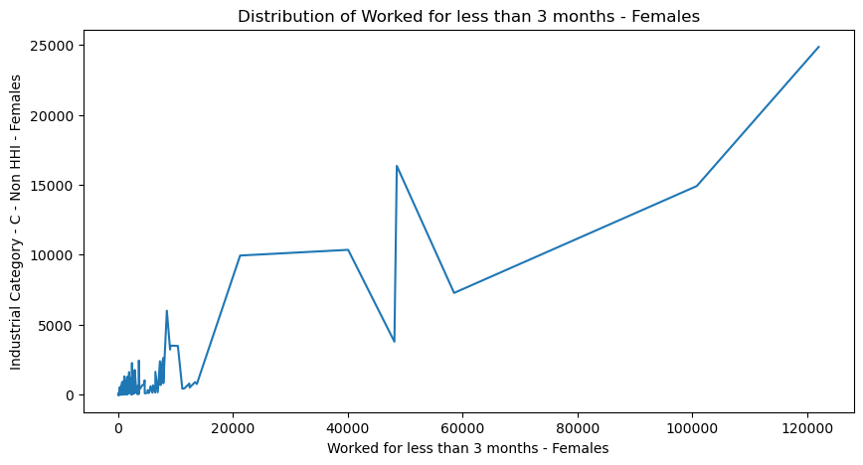

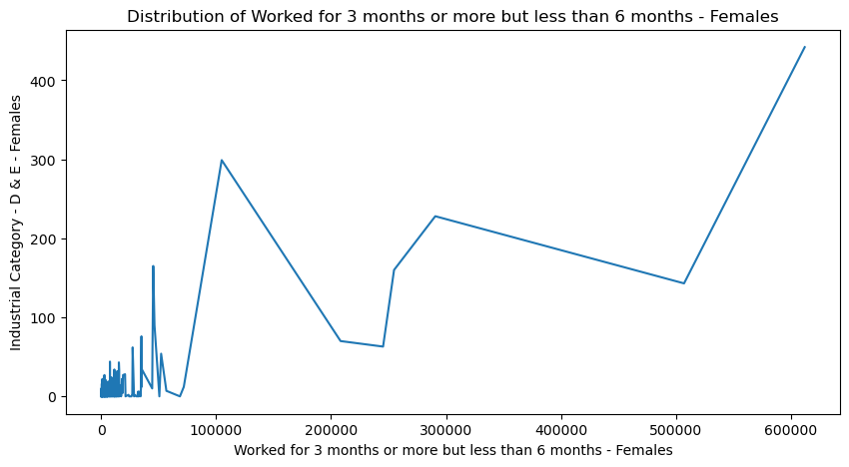

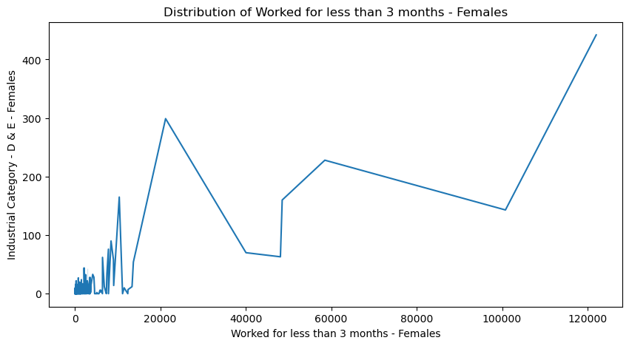

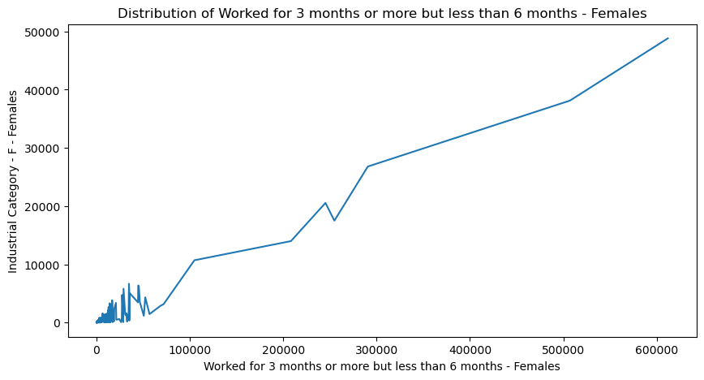

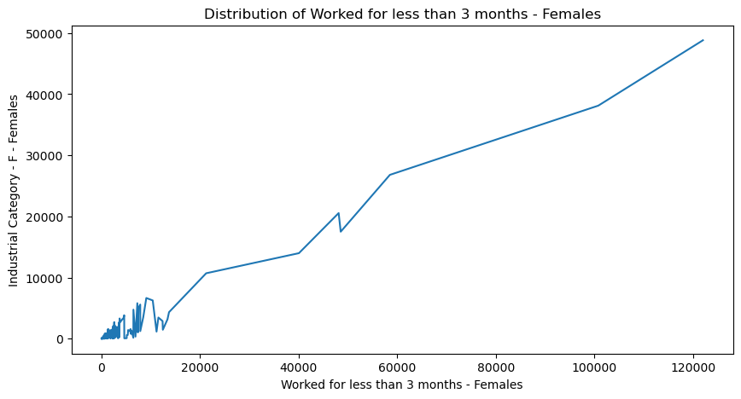

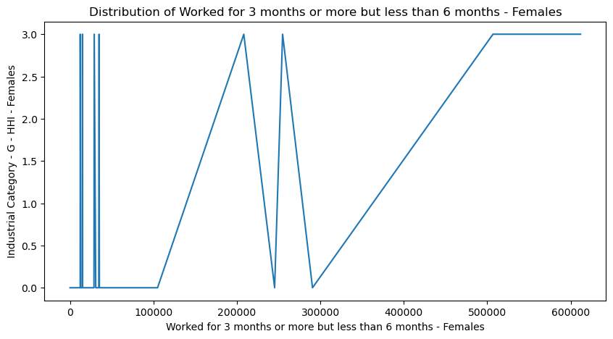

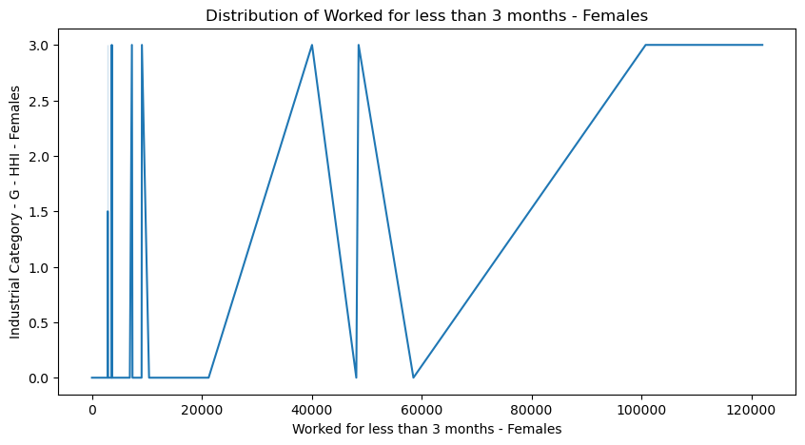

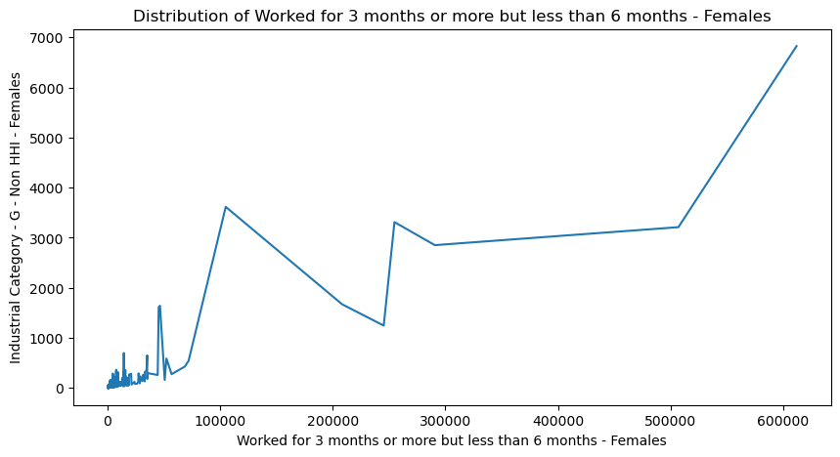

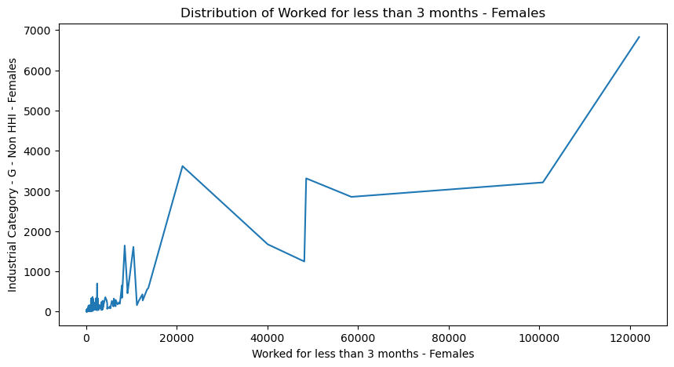

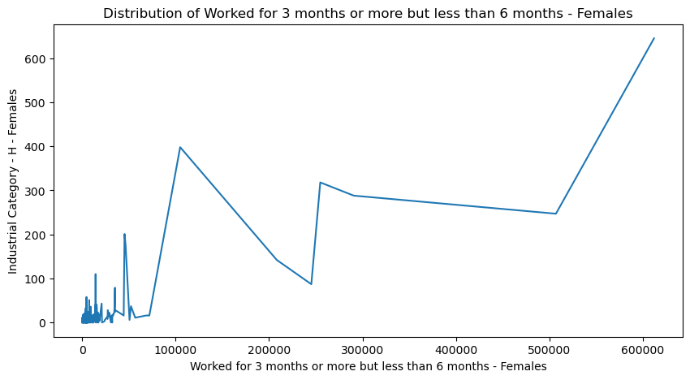

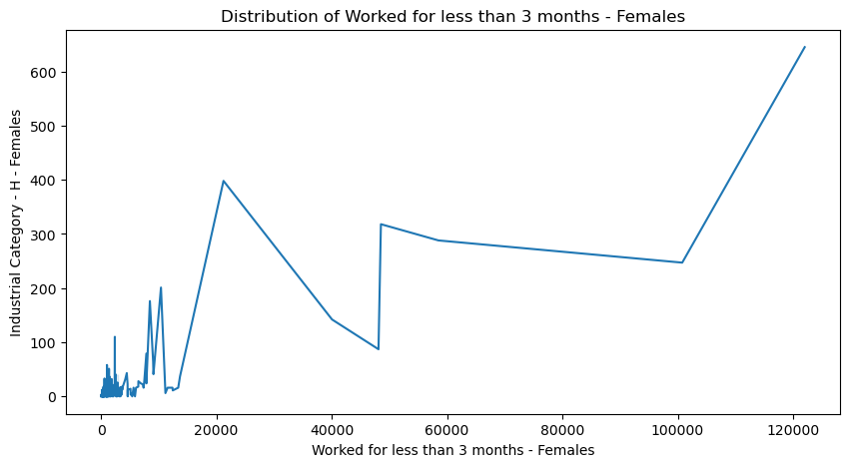

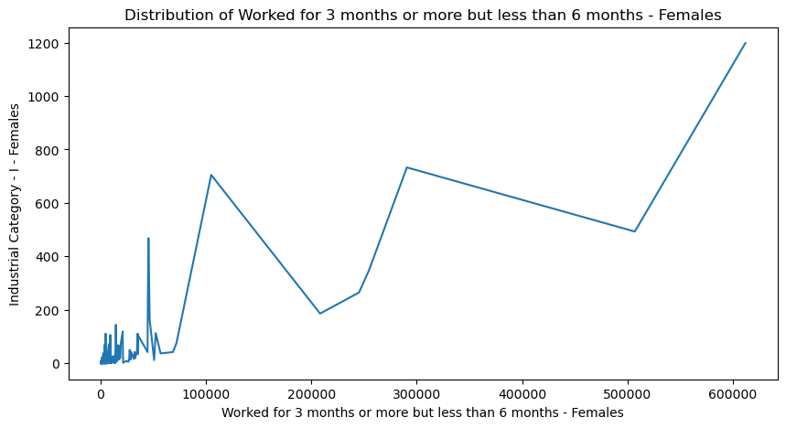

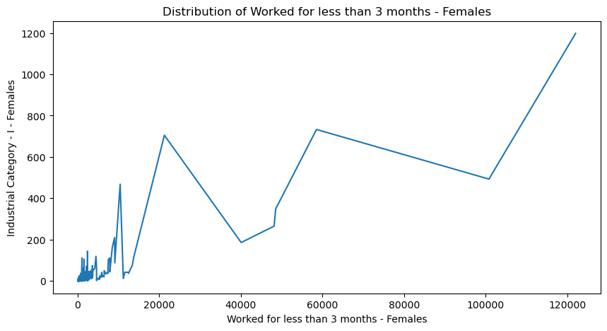

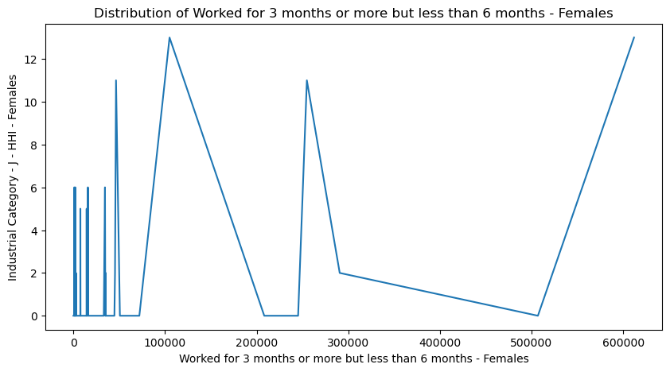

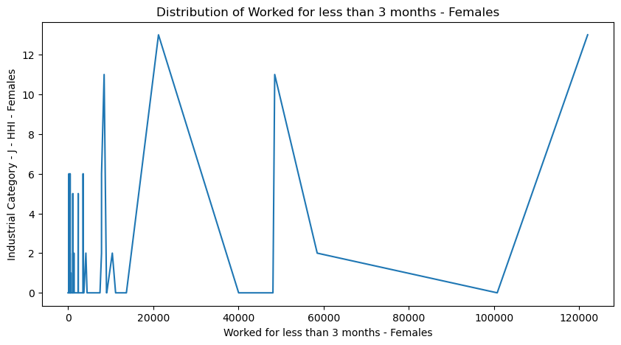

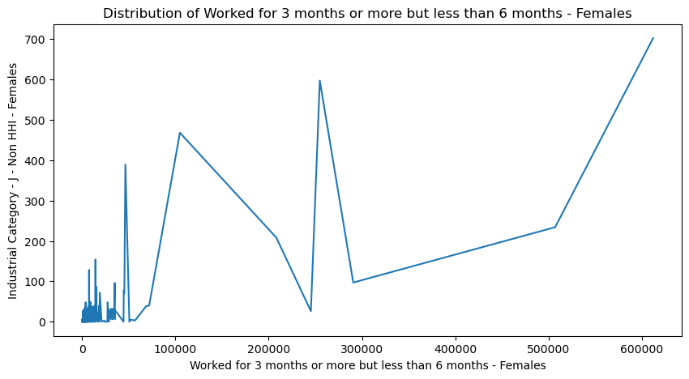

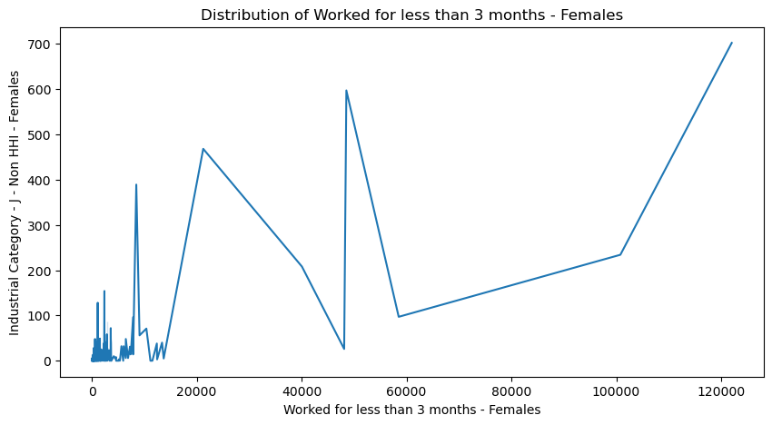

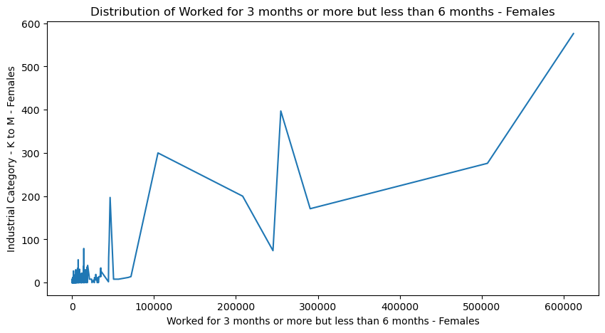

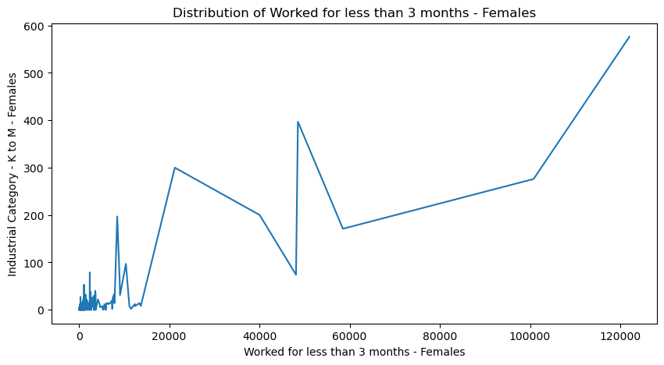

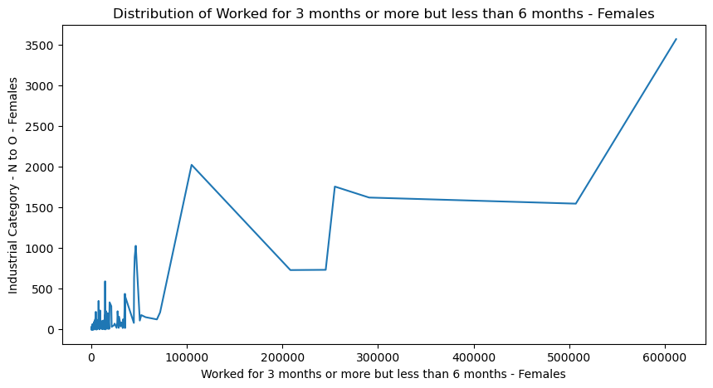

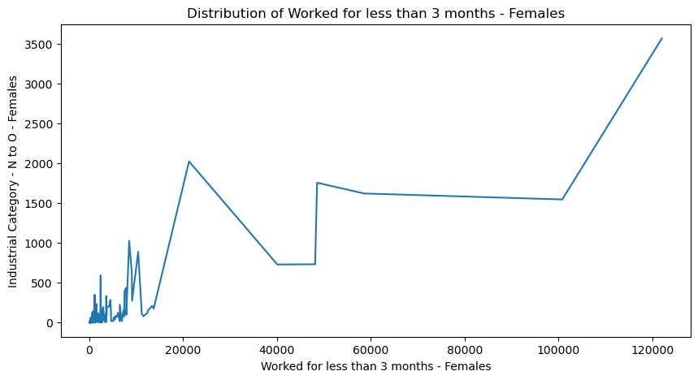

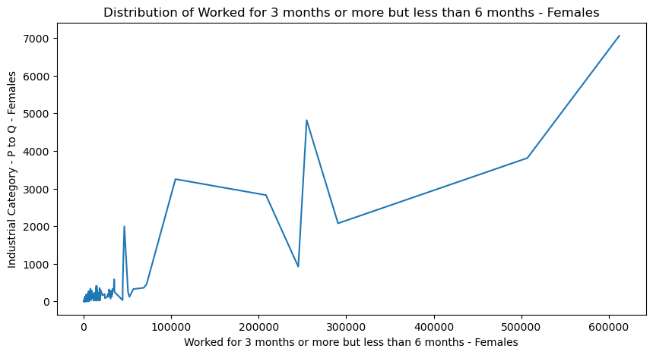

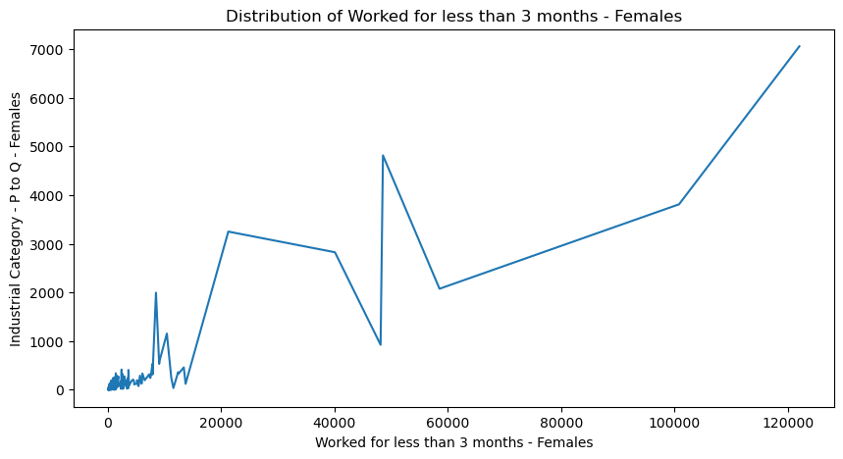

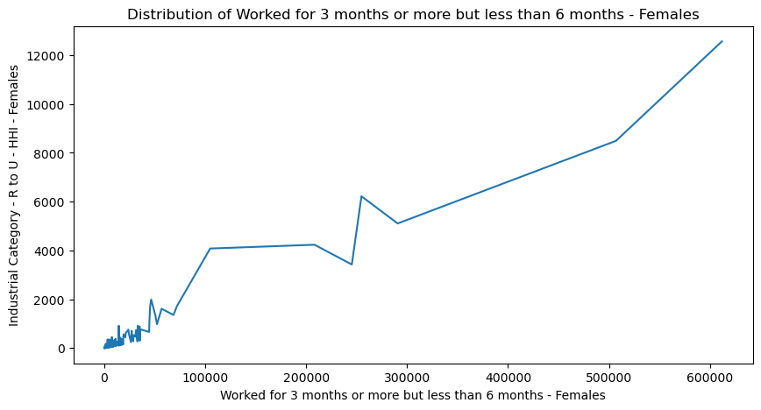

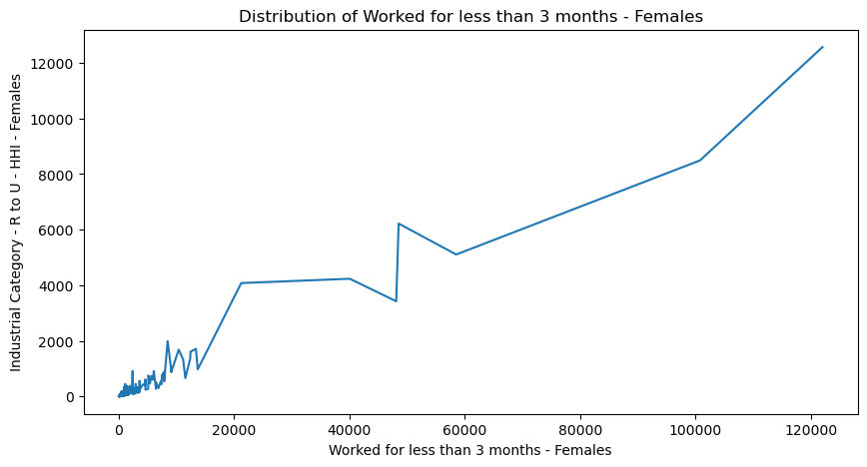

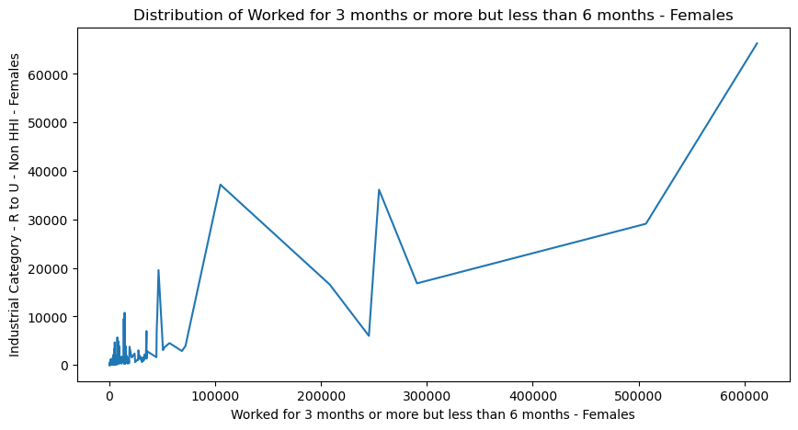

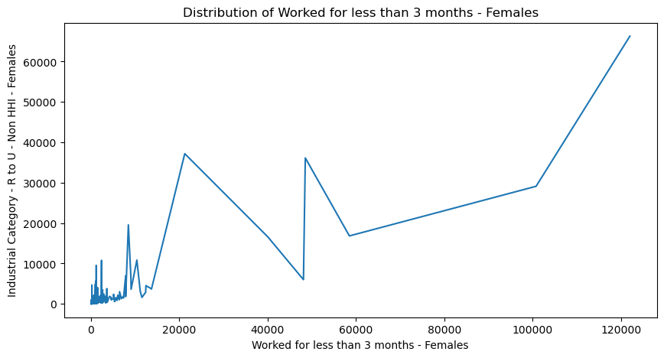

**VISUALIZATION BY INDUSTRIAL CATEGORY PERSON WORKERS**:

for column3 in Industrial_category_person:

for work3 in person_workers:

plt.figure(figsize=(10,5))

sns.lineplot(data=df, x=work3, y=column3)

plt.title(f'Distribution of {work3}')

plt.show()

**OUTPUT:**

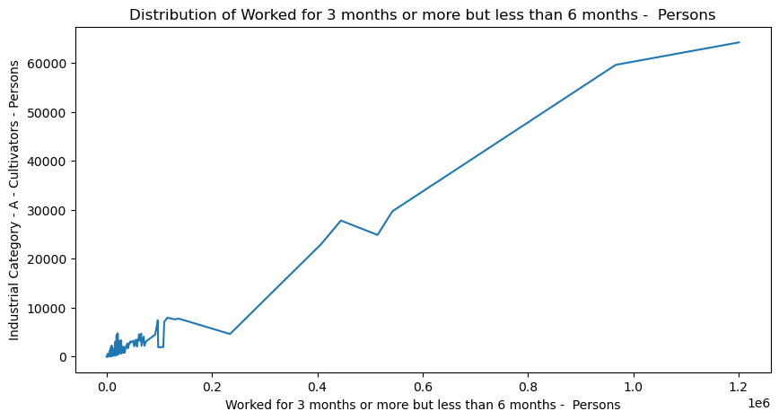

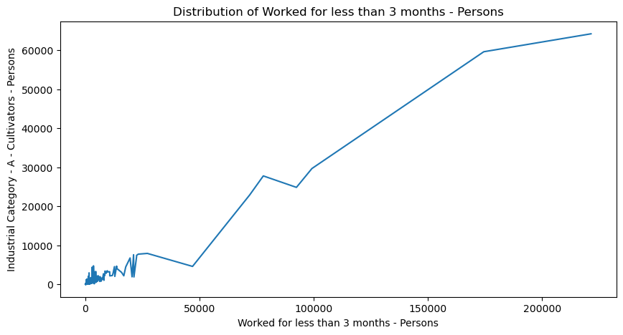

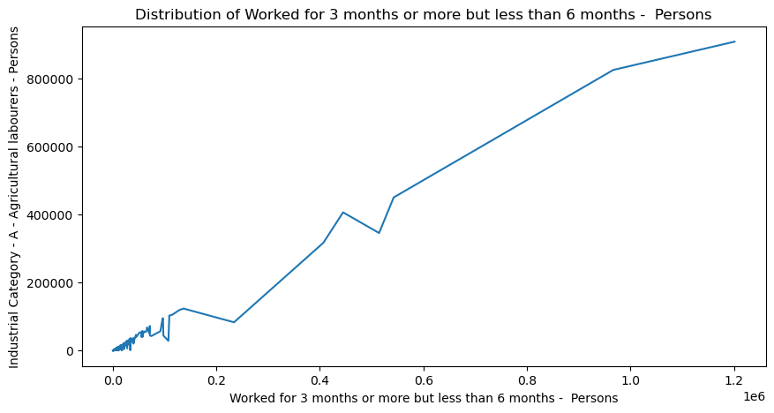

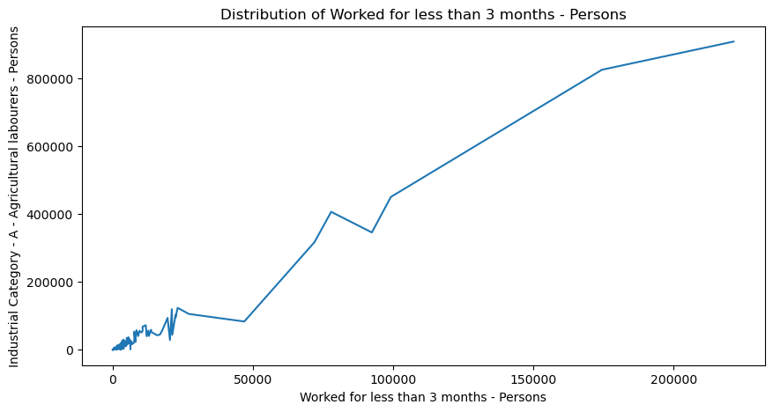

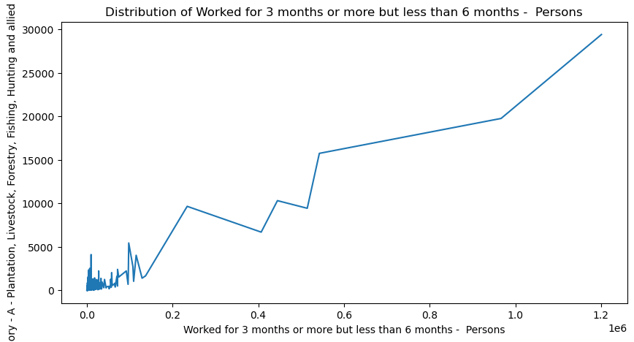

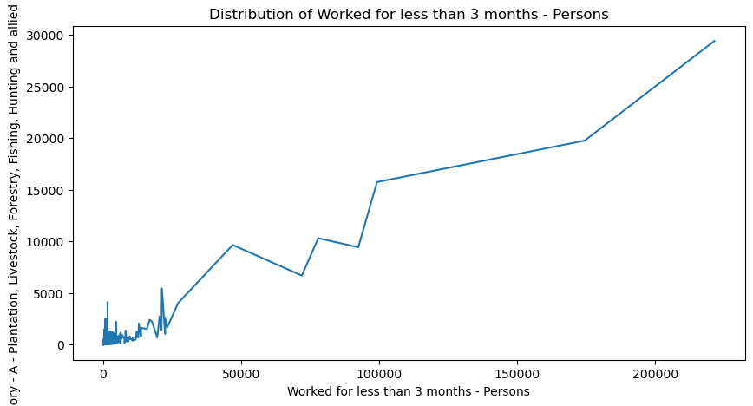

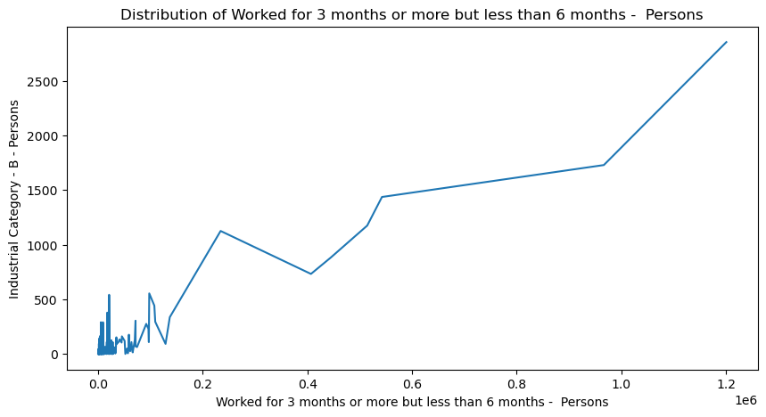

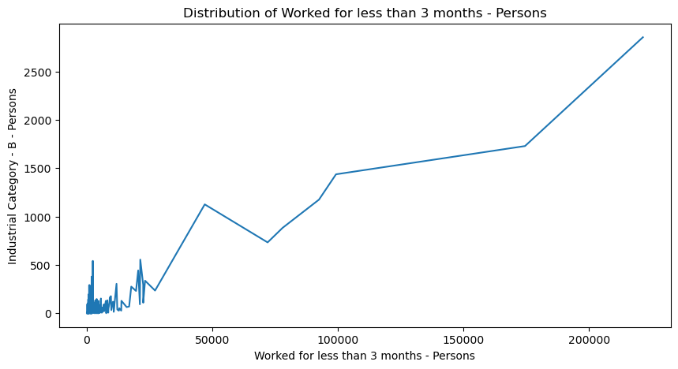

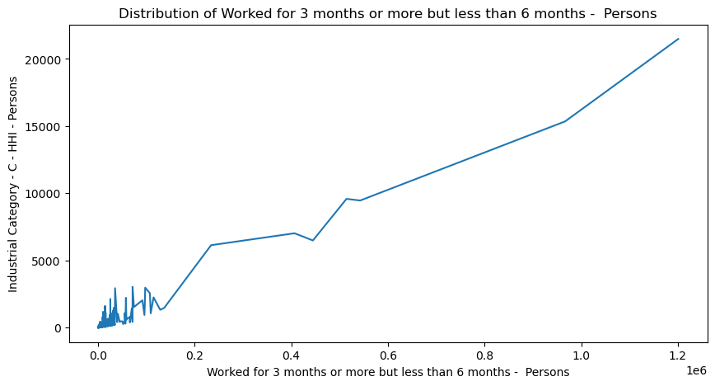

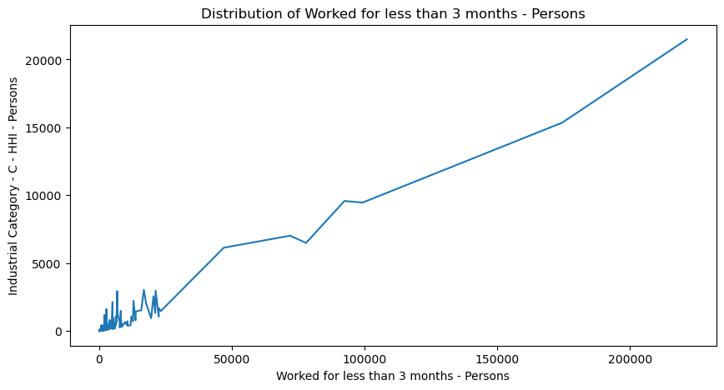

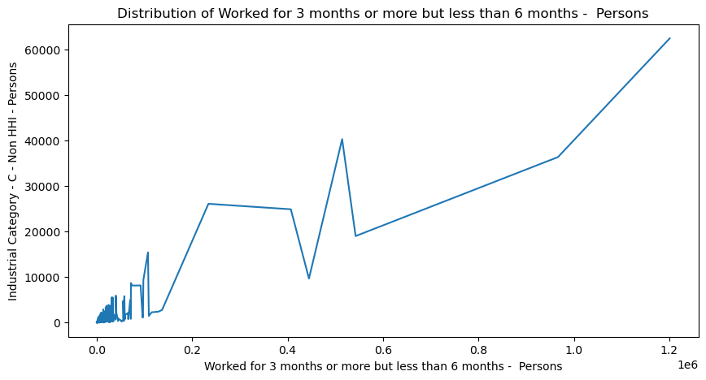

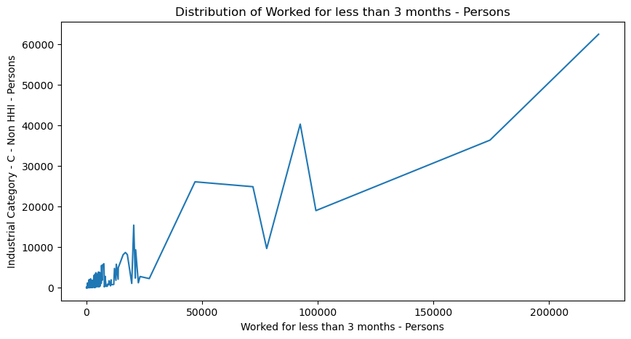

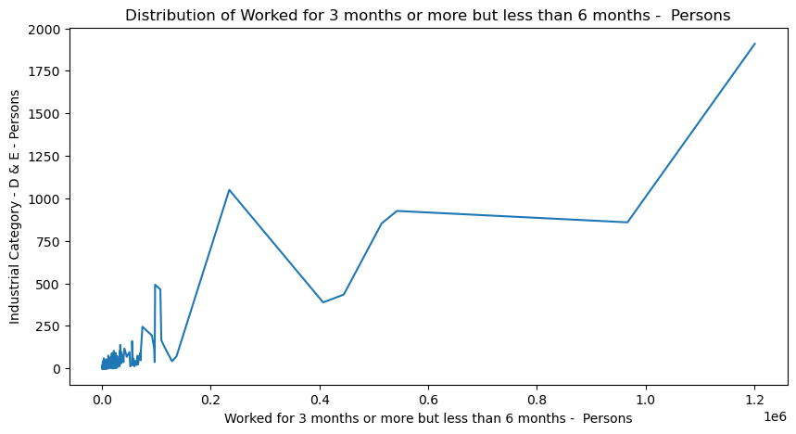

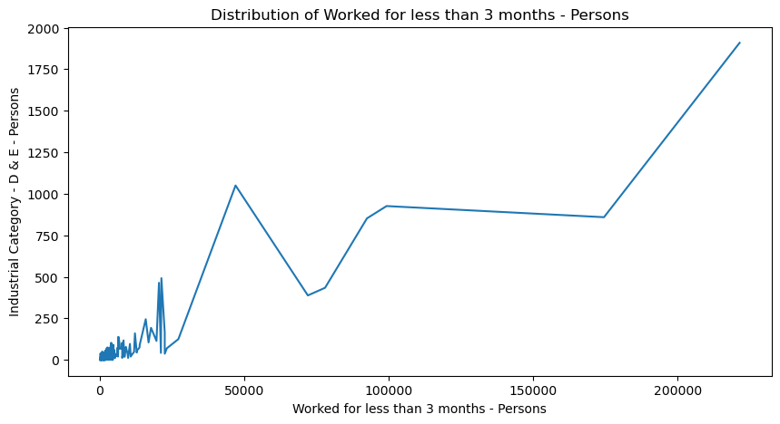

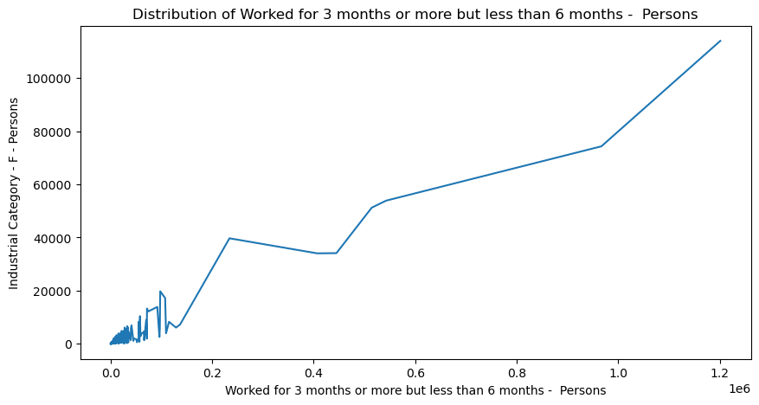

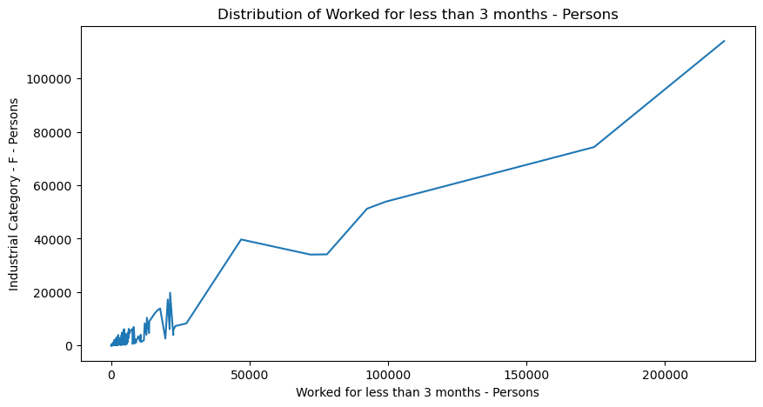

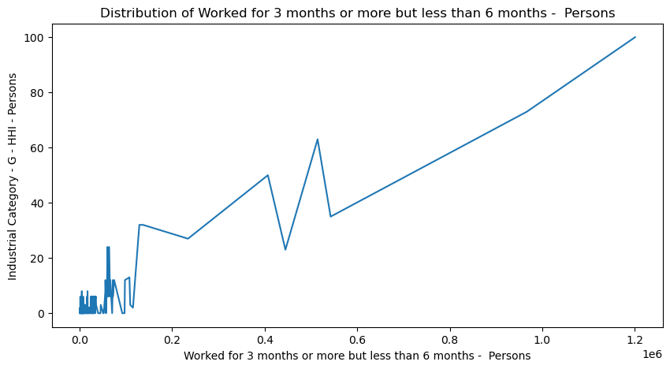

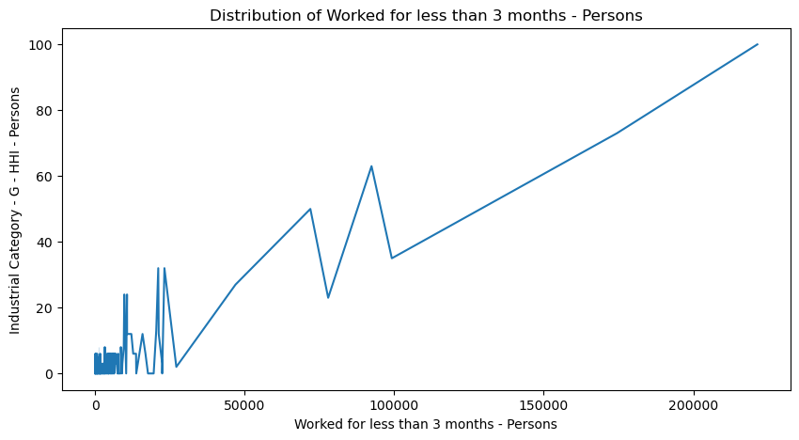

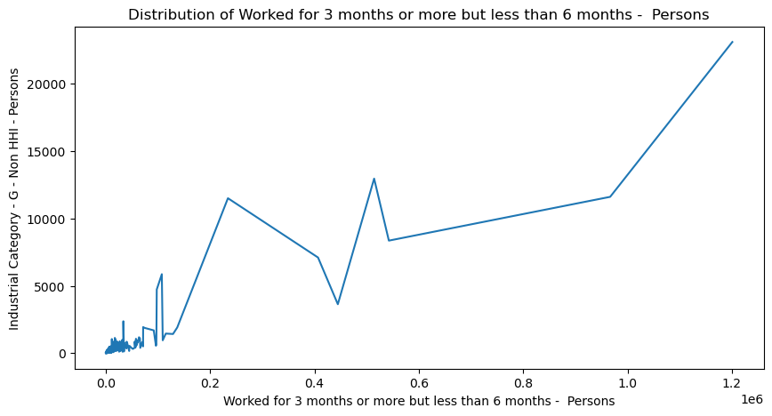

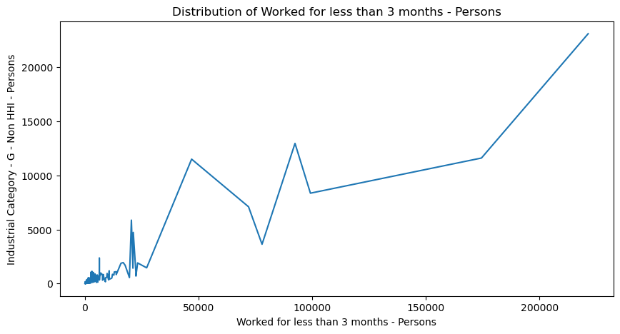

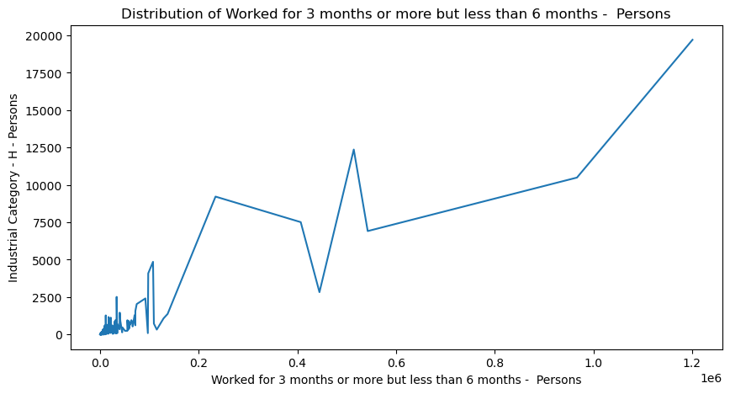

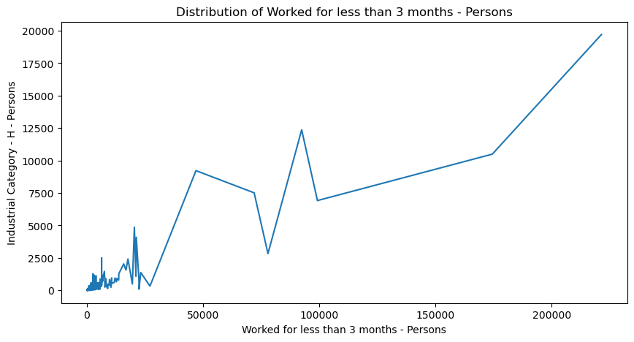

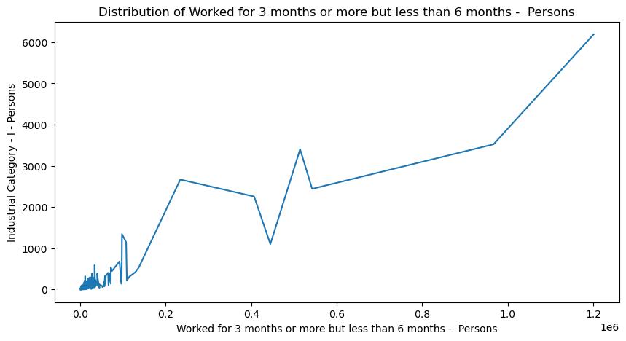

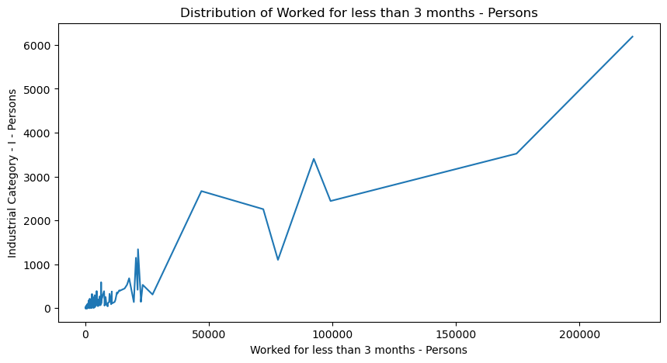

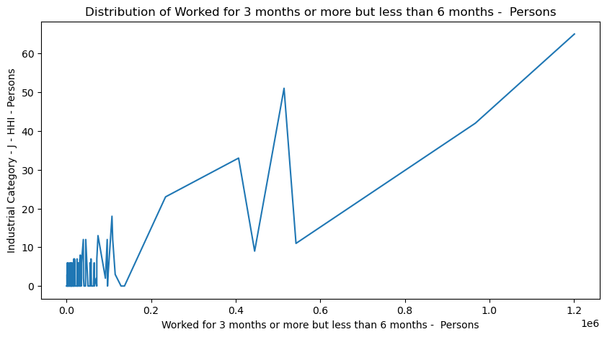

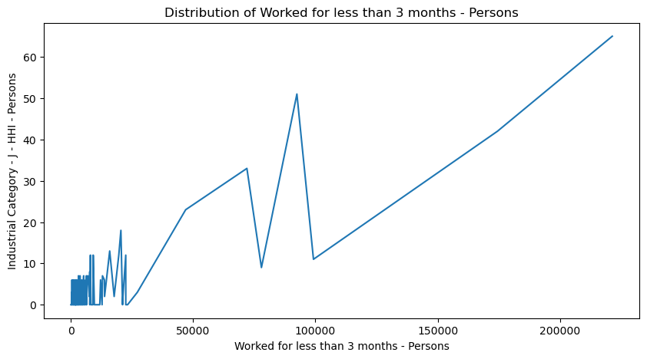

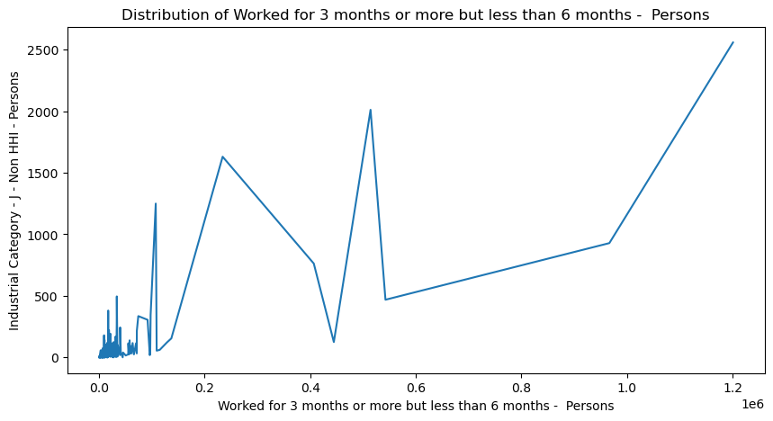

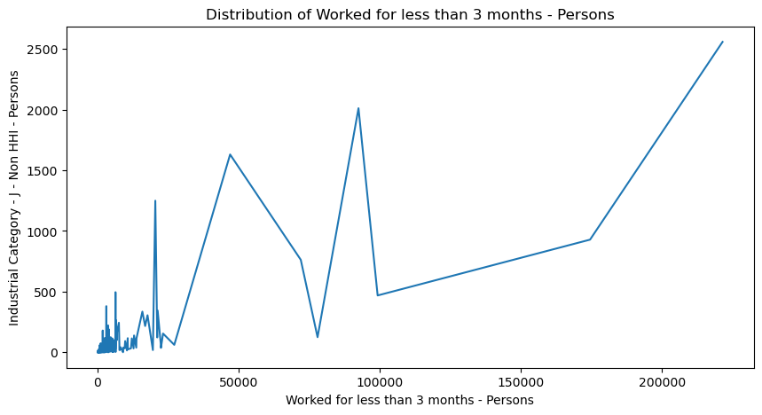

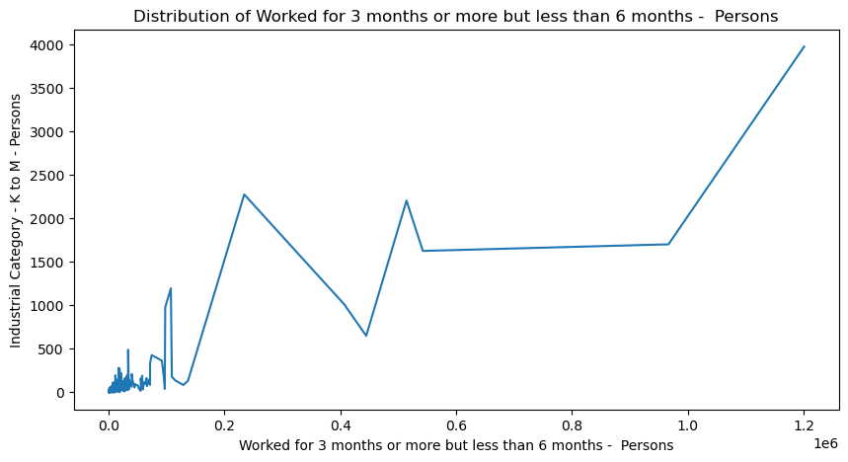

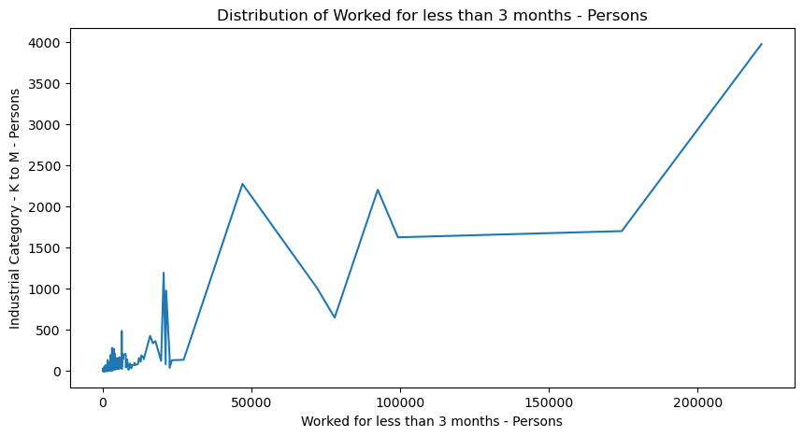

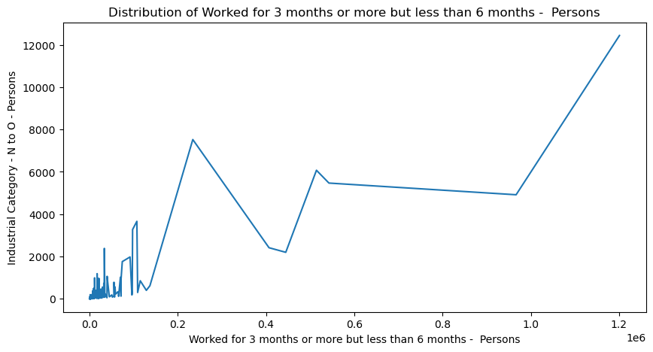

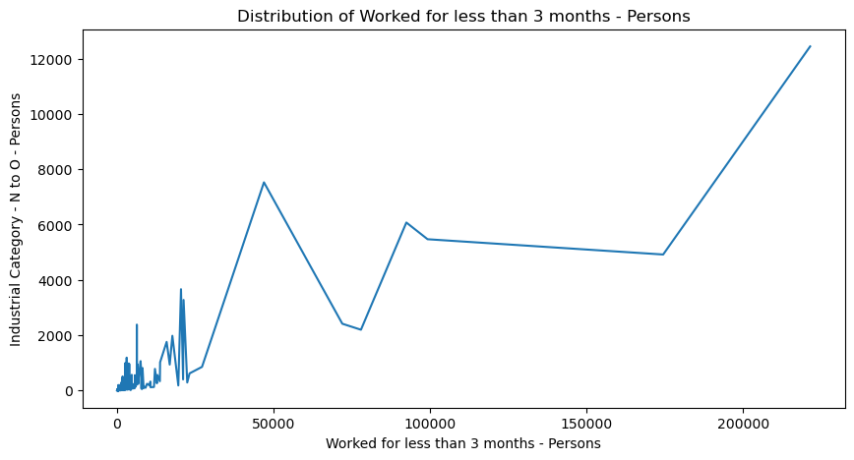

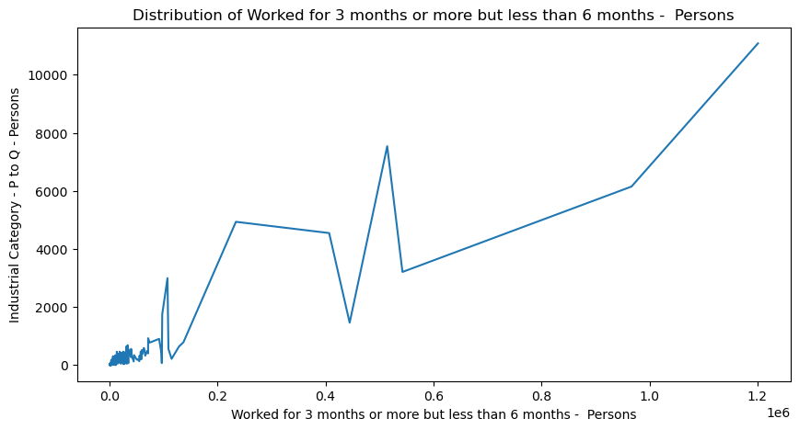

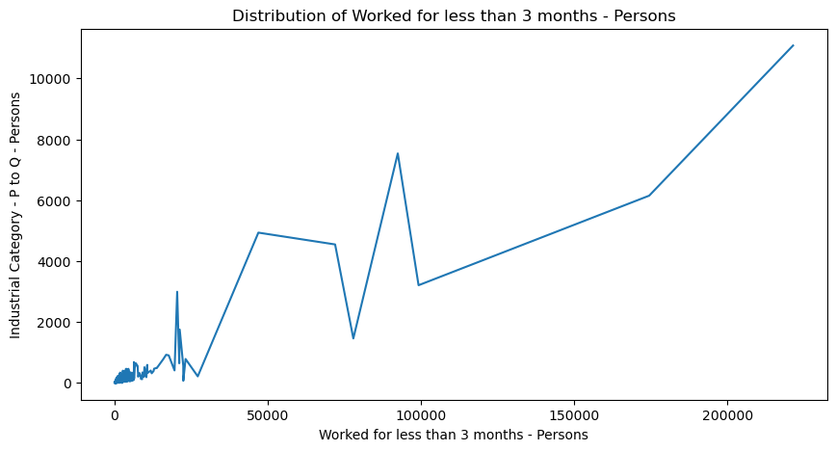

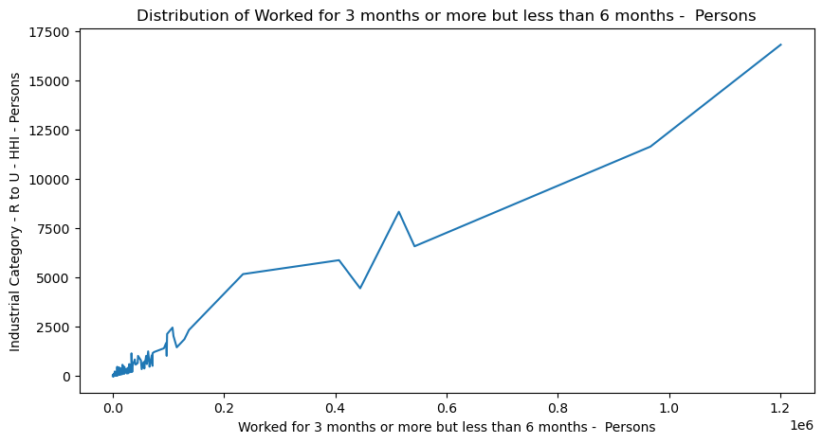

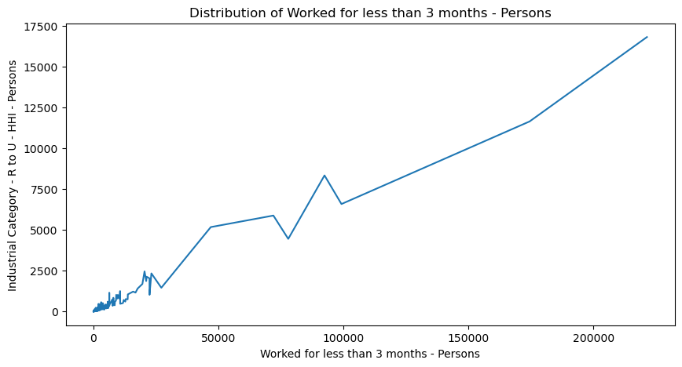

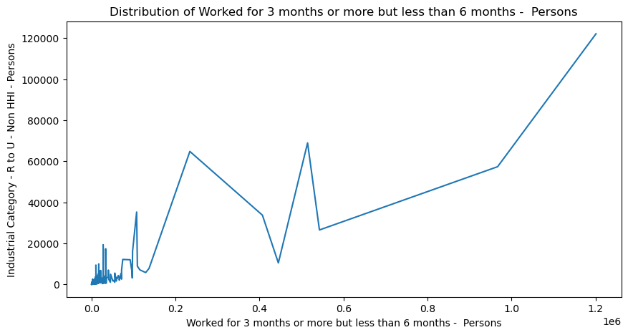

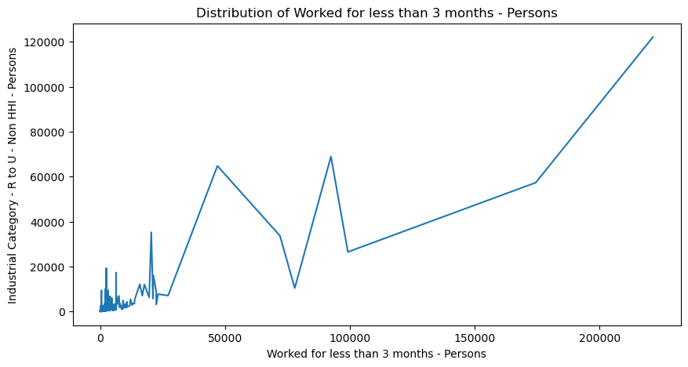

**VALIDATION:**

for colum1, colum2, colum3 in zip(Industrial_category_male, Industrial_category_female, Industrial_category_person):

summary_stats_male = df[colum1].agg(['mean', 'sum'])

summary_stats_female = df[colum2].agg(['mean', 'sum'])

summary_stats_person = df[colum3].agg(['mean', 'sum'])

print(summary_stats_male, '\n')

print(summary_stats_female, '\n')

print(summary_stats_person, '\n')

for work1, work2, work3 in zip(male_workers, female_workers, person_workers):

summary_stats_male = df[work1].agg(['mean', 'sum'])

summary_stats_female = df[co2].agg(['mean', 'sum'])

summary_stats_person = df[colum3].agg(['mean', 'sum'])

**AGGREGATION:**

mean 466.424242

sum 277056.000000

Name: Industrial Category - A - Cultivators - Males, dtype: float64

mean 398.693603

sum 236824.000000

Name: Industrial Category - A - Cultivators - Females, dtype: float64

mean 865.117845

sum 513880.000000

Name: Industrial Category - A - Cultivators - Persons, dtype: float64

mean 25.077441

sum 14896.000000

Name: Industrial Category - B - Males, dtype: float64

mean 6.773172e+03

sum 4.023264e+06

Name: Industrial Category - A - Agricultural labourers - Females, dtype: float64

mean 1.222562e+04

sum 7.262016e+06

Name: Industrial Category - A - Agricultural labourers - Persons, dtype: float64

mean 5.452444e+03

sum 3.238752e+06

Name: Industrial Category - A - Agricultural labourers - Males, dtype: float64

mean 176.996633

sum 105136.000000

Name: Industrial Category - A - Plantation, Livestock, Forestry, Fishing, Hunting and allied activities - Females, dtype: float64

mean 396.094276

sum 235280.000000

Name: Industrial Category - A - Plantation, Livestock, Forestry, Fishing, Hunting and allied activities - Persons, dtype: float64

mean 219.097643

sum 130144.000000

Name: Industrial Category - A - Plantation, Livestock, Forestry, Fishing, Hunting and allied activities - Males, dtype: float64

mean 13.346801

sum 7928.000000

Name: Industrial Category - B - Females, dtype: float64

mean 38.424242

sum 22824.000000

Name: Industrial Category - B - Persons, dtype: float64

mean 105.62963

sum 62744.00000

Name: Industrial Category - C - HHI - Males, dtype: float64

mean 183.744108

sum 109144.000000

Name: Industrial Category - C - HHI - Females, dtype: float64

mean 289.373737

sum 171888.000000

Name: Industrial Category - C - HHI - Persons, dtype: float64

mean 505.319865

sum 300160.000000

Name: Industrial Category - C - Non HHI - Males, dtype: float64

mean 334.653199

sum 198784.000000

Name: Industrial Category - C - Non HHI - Females, dtype: float64

mean 839.973064

sum 498944.000000

Name: Industrial Category - C - Non HHI - Persons, dtype: float64

mean 19.757576

sum 11736.000000

Name: Industrial Category - D & E - Males, dtype: float64

mean 5.952862

sum 3536.000000

Name: Industrial Category - D & E - Females, dtype: float64

mean 25.710438

sum 15272.000000

Name: Industrial Category - D & E - Persons, dtype: float64

mean 878.518519

sum 521840.000000

Name: Industrial Category - F - Males, dtype: float64

mean 657.548822

sum 390584.000000

Name: Industrial Category - F - Females, dtype: float64

mean 1536.06734

sum 912424.00000

Name: Industrial Category - F - Persons, dtype: float64

mean 1.306397

sum 776.000000

Name: Industrial Category - G - HHI - Males, dtype: float64

mean 0.040404

sum 24.000000

Name: Industrial Category - G - HHI - Females, dtype: float64

mean 1.346801

sum 800.000000

Name: Industrial Category - G - HHI - Persons, dtype: float64

mean 219.353535

sum 130296.000000

Name: Industrial Category - G - Non HHI - Males, dtype: float64

mean 91.93266

sum 54608.00000

Name: Industrial Category - G - Non HHI - Females, dtype: float64

mean 311.286195

sum 184904.000000

Name: Industrial Category - G - Non HHI - Persons, dtype: float64

mean 256.740741

sum 152504.000000

Name: Industrial Category - H - Males, dtype: float64

mean 8.686869

sum 5160.000000

Name: Industrial Category - H - Females, dtype: float64

mean 265.427609

sum 157664.000000

Name: Industrial Category - H - Persons, dtype: float64

mean 67.205387

sum 39920.000000

Name: Industrial Category - I - Males, dtype: float64

mean 16.13468

sum 9584.00000

Name: Industrial Category - I - Females, dtype: float64

mean 83.340067

sum 49504.000000

Name: Industrial Category - I - Persons, dtype: float64

mean 0.700337

sum 416.000000

Name: Industrial Category - J - HHI - Males, dtype: float64

mean 0.175084

sum 104.000000

Name: Industrial Category - J - HHI - Females, dtype: float64

mean 0.875421

sum 520.000000

Name: Industrial Category - J - HHI - Persons, dtype: float64

mean 24.996633

sum 14848.000000

Name: Industrial Category - J - Non HHI - Males, dtype: float64

mean 9.454545

sum 5616.000000

Name: Industrial Category - J - Non HHI - Females, dtype: float64

mean 34.451178

sum 20464.000000

Name: Industrial Category - J - Non HHI - Persons, dtype: float64

mean 45.791246

sum 27200.000000

Name: Industrial Category - K to M - Males, dtype: float64

mean 7.757576

sum 4608.000000

Name: Industrial Category - K to M - Females, dtype: float64

mean 53.548822

sum 31808.000000

Name: Industrial Category - K to M - Persons, dtype: float64

mean 119.515152

sum 70992.000000

Name: Industrial Category - N to O - Males, dtype: float64

mean 48.013468

sum 28520.000000

Name: Industrial Category - N to O - Females, dtype: float64

mean 167.52862

sum 99512.00000

Name: Industrial Category - N to O - Persons, dtype: float64

mean 57.454545

sum 34128.000000

Name: Industrial Category - R to U - HHI - Males, dtype: float64

mean 95.097643

sum 56488.000000

Name: Industrial Category - P to Q - Females, dtype: float64

mean 149.225589

sum 88640.000000

Name: Industrial Category - P to Q - Persons, dtype: float64

mean 751.52862

sum 446408.00000

Name: Industrial Category - R to U - Non HHI - Males, dtype: float64

mean 169.252525

sum 100536.000000

Name: Industrial Category - R to U - HHI - Females, dtype: float64

mean 226.707071

sum 134664.000000

Name: Industrial Category - R to U - HHI - Persons, dtype: float64